 D00258.00017

AIRPORT FWD DATA ANALYZER
Backcalculation User Manual
Prepared for:


Prepared by:
Applied Research Associates, Inc.
Mid-Atlantic Division
2628 Fire Road
Suite 300
Egg Harbor Township, NJ 08234

March 3, 2023
Contract No. 692M15-21-D-00004
Order No. 692M15-22-F-00129
Task Order 17
NDT for Structural Evaluation of Airport Pavements
Deliverable: 5.2.1.1 Update Upgraded BAKFAA User Manual, Help Files, and Presentation

Table of Contents
Chapter 1. Introduction to BAKFAA 1
Chapter 2. Installation of BAKFAA 2
2.1 Installation Requirements 2
2.1.1 Operating System Requirements 2
2.1.2 Hardware Requirements 2
2.2 Installation Process 2
2.3 How to Uninstall the BAKFAA Application 4
2.4 Running the Program 4
Chapter 3. BAKFAA Interface 6
3.1 BAKFAA Modular Interface 6
3.1.1 Interface Definitions 7
3.1.2 Configuring the Modular Interface 10
3.2 BAKFAA Version and FWD File Location 13
3.3 Pavement Layer Structure 14
3.3.1 Seed Modulus 18
3.3.2 Backcalculated Modulus 19
3.3.3 Poisson’s Ratio 19
3.3.4 Interface Parameter 20
3.3.5 Pavement Layer Thicknesses 21
3.3.6 Moduli Changeable 21
3.4 Saving and Loading Pavement Section 21
3.5 Units 22
3.6 FWD Test Information 27
3.6.1 Load FWD Files 30
3.6.2 View FWD File 33
3.6.3 Convert FWD File to PDDX Format 34
3.6.4 FWD File Parser 35
3.7 Selection of FWD Drops for Backcalculation 39
3.8 Backcalculation Analysis 40
3.8.1 Iteration Tolerance 41
3.8.2 Iteration Number 42
3.8.3 Root Mean Square Error 42
3.8.4 Backcalculated Modulus 42
3.8.5 Calculated Deflections 42
3.8.6 .CSV Output File 43
3.8.7 Show Output 43
3.8.8 Abort an In-Progress Backcalculation 44
3.9 Batch Graph 45
3.10 Load Transfer Efficiency (LTE) Calculation 46
Chapter 4. Select Load and Run LEAF 49
4.1 Load and Gear Configuration 50
4.2 LEAF Output 53
Chapter 5. Sample BAKFAA Analysis 55
5.1 Flexible Pavement Example 55
5.2 Rigid Pavement Example 59
5.3 Composite Pavement Example 64
5.4 LTE Calculation Example 69
5.5 Error Messages 70
5.5.1 User Input Errors 70
5.5.2 FWD File Error 71
Chapter 6. Advice and Reminders 72
Chapter 7. References 73

List of Figures
Figure 2-1. BAKFAA installation welcome dialog box 3
Figure 2-2. BAKFAA installation dialog 3
Figure 2-3. BAKFAA in the Windows Start button program menu 5
Figure 2-4. BAKFAA Windows desktop shortcut icon 5
Figure 3-1. Default BAKFAA interface 6
Figure 3-2. Interface showing window types and floating tab 8
Figure 3-3. Interface showing the header, toolbar, and modules 9
Figure 3-4. Interface showing document and tab types, and grouping 9
Figure 3-5. Adjusting interface module size 10
Figure 3-6. Positioning a module in the GUI (a) adding to group of tabs (b) placing as adjacent tab (c) placing as tab on edge of window (d) collapsing a tab (e) floating window/tab 13
Figure 3-7. Changing title order in module group 13
Figure 3-8. a) Default interface displaying BAKFAA version and b) location/name of the file in use after loading the file 14
Figure 3-9. Defining pavement structure in BAKFAA 15
Figure 3-10. Selecting pavement type in BAKFAA 15
Figure 3-11. Adding or deleting a pavement layer in BAKFAA 16
Figure 3-12. Layer Property menu used to add a pavement layer 17
Figure 3-13. Pavement structure submodule 18
Figure 3-14. Saving and loading pavement sections 21
Figure 3-15. Example of pavement section .XML file containing FWD test and pavement structure data 22
Figure 3-16. Selection of Units 23
Figure 3-17. Default FWD test setup shown in English units 24
Figure 3-18. Default FWD test setup shown in Metric units 25
Figure 3-19. FWD file sub-window shown in English units 26
Figure 3-20. FWD file sub-window shown in Metric units 27
Figure 3-21. Default FWD test setup 28
Figure 3-22. Exclusion of sensor warning 29
Figure 3-23. Calculated deflections and updated deflection graph after backcalculation analysis 30
Figure 3-24. (a) Loading a FWD file and (b) Selecting a drop 32
Figure 3-25. Viewing details of an FWD station 33
Figure 3-26. FWD file sub-window 34
Figure 3-27. Example of delimited data file and the extraction of software edition 36
Figure 3-28. Extraction of software edition from Dynatest R32 file with fixed-width format 36
Figure 3-29. Example a two-level split extraction 37
Figure 3-30. Example of functionality of “Translate” section of the XML file 38
Figure 3-31. Example of functionality of “AssignedData” section of the XML file 38
Figure 3-32. FWD drop selection in the “FWD Drops” module and the “Select Drops”, “Select All”, and “Clear All” buttons 40
Figure 3-33. FWD drop selection using the “Select Drops” button and the “Drop No.” menu 40
Figure 3-34. Start batch backcalculation analysis 41
Figure 3-35. “Show Output” sub-window displaying backcalculation results of a batch analysis 44
Figure 3-36. “Batch Graph” sub-window displaying measured and calculated deflections 46
Figure 3-37. “Batch Graph” sub-window displaying backcalculated modulus values 46
Figure 3-38. LTE cases 47
Figure 3-39. LTE calculation in BAKFAA 48
Figure 4-1. Pavement structure and evaluation depth settings for LEAF analysis 49
Figure 4-2. Load Library for LEAF analysis 51
Figure 4-3. Summary of items in the LEAFAircraft.Ext file for a B-747-400 example 52
Figure 4-4. Schematic of B-747-400 Landing Gear Parameters in the LEAFAircraft.Ext file 53
Figure 5-1. Backcalculation results for flexible pavement example (first attempt) 57
Figure 5-2. Backcalculation results for flexible pavement example (second attempt) 58
Figure 5-3. Backcalculation results for flexible pavement example (third attempt) 58
Figure 5-4. Backcalculation results for rigid pavement example (first attempt) 60
Figure 5-5. Backcalculation results for rigid pavement example (second attempt) 61
Figure 5-6. Backcalculated layer modulus values for all test points for drop no. 3 in rigid pavement example 62
Figure 5-7. Deflection basin at DMI of 6,600 ft. showing unusual deflections in the rigid pavement example 63
Figure 5-8. FWD data for DMI of 6,600 ft. removed using the “View FWD File” sub-window in the rigid pavement example 63
Figure 5-9. Backcalculation analysis using default seed modulus values in the composite pavement example 66
Figure 5-10. Backcalculated layer modulus values for drop no. 2 at all test points using default seed modulus in the composite pavement example 66
Figure 5-11. Backcalculation analysis using temperature-adjusted P-401 modulus in the composite pavement example 67
Figure 5-12. Backcalculated layer modulus values for drop no. 2 at all test points using temperature-adjusted P-401 seed modulus in the composite pavement example 67
Figure 5-13. Backcalculation analysis using fixed P-401 modulus value in the composite pavement example 68
Figure 5-14. Backcalculated layer modulus values for drop no. 2 at all test points using fixed P-401 modulus value in the composite pavement example 68
Figure 5-15. LTE calculation example 70

List of Tables
Table 2-1. CPU and RAM requirements for running BAKFAA 3.4 2
Table 2-2. List of installed application files 4
Table 3-1. Typical modulus values and ranges for paving material 19
Table 3-2. Default seed modulus and Poisson’s ratio values for pavement layers in BAKFAA 20
Table 3-3. English and Metric units used for illustration of different entities in BAKFAA 23
Table 3-4. File types supported by BAKFAA 31
Table 3-5. Available specifications for KUAB and CarlBro file types 39
Table 4-1. Critical locations in analysis of pavement structure responses 50
Table 5-1. Composition of pavement layers for the flexible pavement example 55
Table 5-2. Flexible pavement example backcalculated layer modulus values and statistics 59
Table 5-3. Composition of pavement layers for the rigid pavement example 59
Table 5-4. Rigid pavement example layer modulus values and statistics 64
Table 5-5. Composition of pavement layers for the composite pavement example 64
Table 5-6. Composite pavement example backcalculated layer modulus values and statistics for three approaches 69

List of Acronyms
BAKFAA The FAA software to perform backcalculation of pavement material properties using Heavy Weight Deflectometer/Falling Weight Deflectometer data
CPU Central Processing Unit
CSV Comma Separated Values
GUI Graphical User Interface
LEAF FAA Layered Elastic Analysis program
LTE Load Transfer Efficiency
FWD Falling Weight Deflectometer
HMA Hot Mix Asphalt
HWD Heavy Weight Deflectometer
PCC Portland Cement Concrete
RAM Random Access Memory
RMSE Root Mean Square Error
XML Extensible Markup Language

Introduction to BAKFAA
BAKFAA is a computer program developed by the Federal Aviation Administration (FAA) for backcalculation of pavement layer moduli using heavy weight deflectometer/falling weight deflectometer (HWD/FWD) data. BAKFAA uses the FAA Layered Elastic Analysis Program (LEAF) as the forward method to simulate the FWD load and to calculate pavement deflections. The backcalculation process is based on an iterative mathematical process to find a combination of layer moduli such that the root mean square (RMS) error of the measured and LEAF computed deflection basins is minimized. BAKFAA employs a downhill multi-dimensional simplex as the optimization method. The minimization procedure is a direct implementation of sets of routines in Section 10.4 of “Numerical Recipes in Fortran” by Press et al, 1992. The routines were translated from Fortran into Visual Basic to be applied in the BAKFAA program. BAKFAA Version 3.4 (BAKFAA 3.4) was developed in Microsoft Visual Studio 2019 and compiled under .NET Framework 4.5.

Installation of BAKFAA

Installation Requirements
BAKFAA is developed in Microsoft Visual Studio 2019 using the Visual Basic .NET programming language (VB>NET) and compiled under .NET Framework 4.5. BAKFAA installation must meet .NET Framework 4.5 basic installation requirements.

Operating System Requirements
- Windows XP Home or Windows XP Professional, both with Service Pack 2 or later.
- Windows Server 2003 family with Service Pack 1 or later.
- Windows Vista.
- Windows Server 2008.
- Windows 7.
- Windows 8.
- Windows 10.

Hardware Requirements
Table 2-1 lists the Central Processing Unit (CPU) and Random Access Memory (RAM) requirements for running an application under the .NET Framework 4.5.
Table 2-1. CPU and RAM requirements for running BAKFAA 3.4
 | CPU Required | RAM Required
Minimum | Pentium 400 MHz | 96 MB
Recommended | Pentium 1 GHz or higher | 256 MB or more

Installation Process
Use the following link to download and save the BAKFAA application setup package from the FAA website:
https://www.airporttech.tc.faa.gov/Products/Airport-Pavement-Software-Programs
Administrative rights are required to install BAKFAA. Once installed, the user does not require administrative rights to run BAKFAA.
Double click on BAKFAA Installer.msi to launch BAKFAA installation. The installation process consists of a series of dialog boxes similar to the one shown in Figure 2-1. Follow the prompts to install the software. A system dialog box asking if the user wants to allow the program to make changes to the computer may appear. Click “Yes” to continue the installation process. The default installation directory is C:\Program Files\FAA\BAKFAA. The installer will create this directory if it does not already exist. The user can change the default directory by providing a different address. The user may be required to enter an administrator password at this point (Figure 2-2). Click the “Finish” button and exit the setup wizard.

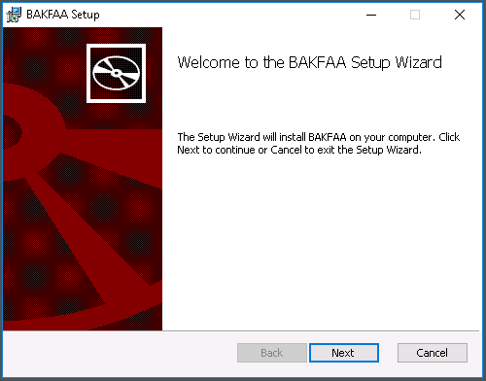
Figure 2-1. BAKFAA installation welcome dialog box
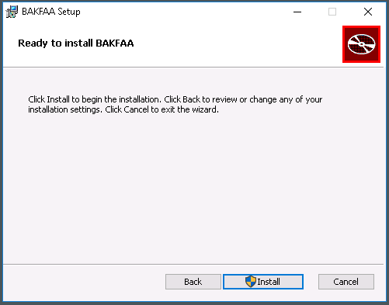
Figure 2-2. BAKFAA installation dialog
Upon installation completion, the application files listed in Table 2-2 are created in the BAKFAA installation folder.
Table 2-2. List of installed application files
No. | File Name | Description
1 | BAKFAA.pdb | Program Debug Database containing BAKFAA debug info
2 | BAKFAA.xml | XML document containing identification & summary of functionality of subroutines and classes added to BAKFAA in Phase II
3 | LEAFClassLib.dll | Class Library containing LEAF
4 | LEAFClassLib.pdb | Program Debug Database containing LEAF debug info
5 | LEAFAircraft.Ext | ASCII Text file containing aircraft gear configurations
6 | System.Windows.Controls.DataVisualization.Toolkit.dll | Reference for user interface
7 | System.Windows.Controls.Input.Toolkit.dll | Reference for user interface
8 | System.Windows.Controls.Layout.Toolkit.dll | Reference for user interface
9 | System.Windows.Interactivity.dll | Reference for user interface
10 | WPFToolkit.dll | Reference for user interface
11 | XMLOutput_template.xml | Template for saving application data

How to Uninstall the BAKFAA Application
To uninstall the BAKFAA application, click the BAKFAA Installer.msi file and select “Remove” when the BAKFAA setup dialog box appears. Confirm the selection by clicking “Next” and the removal process will begin.

Running the Program
BAKFAA can be run from the start menu or desktop. By default, the installer creates a start menu item called BAKFAA. To run the program from the start menu, click the Windows Start button, locate BAKFAA in the Windows program menu as shown in Figure 2-3, and click the BAKFAA menu item to start the program.
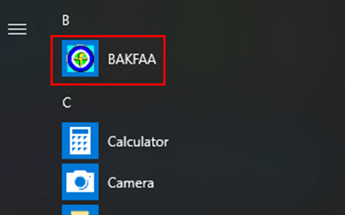
Figure 2-3. BAKFAA in the Windows Start button program menu
The installer also creates a shortcut icon on the desktop called “BAKFAA” by default, as shown in Figure 2-4. To run from the desktop, double click the BAKFAA icon to start the program.


Figure 2-4. BAKFAA Windows desktop shortcut icon

BAKFAA Interface
The BAKFAA interface (Figure 3-1) consists of modules that display pavement section, FWD data file, and backcalculation analysis information in a user-configurable and easily understood format. Upon opening the software, a sample pavement structure is loaded with default layers and material properties. The user can edit this structure and save it for later use or load a previously saved structure from a file. The user can load an FWD data file, review its information, edit the data, and save the updated file. When performing an analysis, the user can select an individual FWD drop and perform a single backcalculation analysis or select multiple drops and perform batch analysis. The Load and Run LEAF option allows the user to perform layered elastic analysis.
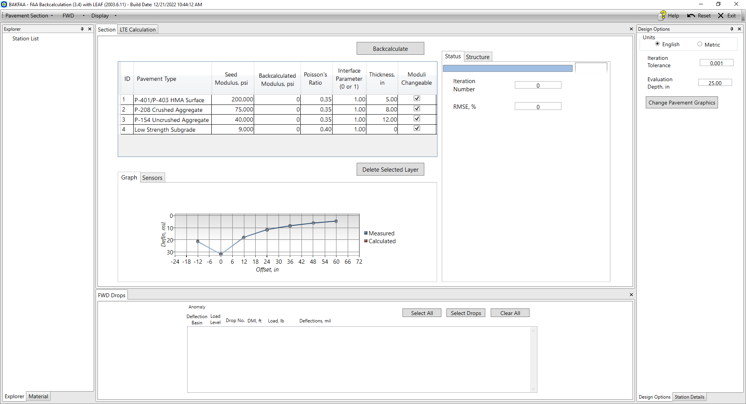
Figure 3-1. Default BAKFAA interface

BAKFAA Modular Interface
BAKFAA’s graphical user interface (GUI) received an overhaul for version 3.4. Instead of a single main window, program functions are divided into ‘modules’ that each serve a specific purpose. The configuration of the modules is user adjustable. Each module can be resized, moved, and even removed to suit the user’s preferences using an intuitive control set. The GUI is unified by a top toolbar which includes main program controls. The “Reset” button in the top right corner resets the GUI to the default layout (including position and size) while all input and output information is retained. The modular interface only changes how BAKFAA looks; the program’s functions remain the same.
The following modules are included in BAKFAA:
- Section – shows pavement structure, deflection information, and backcalculation controls
- FWD Drops – displays the FWD file data (if a file is loaded) and drop selection controls
- Select Load – displays the LEAF load library for various loading configurations
- Design Options – includes design and display controls
- LTE Calculation – performs Load Transfer Efficiency (LTE) calculations
- Explorer – lists FWD stations and drops
- Material – presents available pavement materials
- Station Details – shows information for all drops at the selected location

Interface Definitions
The user has a great deal of freedom to alter the GUI, allowing for easier and faster workflow according to individual preference. To describe the available options, the relevant terms for the BAKFAA user interface are defined in this section.
- Window – Contains the entire BAKFAA program (see Figure 3-2).
  - Main Window – Contains the header and toolbar, at minimum, and contains all modules by default.
  - Floating Window – Auxiliary window containing at least one module.
  - Sub-Window – A single window used in certain display and output functions, ex. the “Batch Graph” sub-window. This cannot be controlled like a module.
- Header – Information shown at the top of the main window. This cannot be moved.
- Toolbar – Contains options and drop-down menus in main window. This cannot be moved.
- Module – A single interface unit that corresponds to a certain function. This can be adjusted by the user (see Figure 3-3).
  - Title – The name of the module. The location of the title depends on the module position type.
  - Submodule – Tabbed interface item within a module that cannot be adjusted.
- Module Position Type – How a module is positioned, which controls how it is displayed. All module position types are defined below. Position has no effect on module function.
  - Document – Embedded in the main window. Its title is positioned at the top of the module in a tabbed format (see Figure 3-4).
  - Tab – Shows title at the top, as well as in a tabbed format at the bottom when grouped (see Figure 3-4). Can be configured in the different ways described below.
    - Docked Tab – Embedded in the main window.
    - Collapsible Tab – Embedded on the edge of the main window. The tab pops out when its title is clicked, and auto-hides when unselected.
    - Floating Tab – A single tab or multiple tabs in a floating window (see Figure 3-2).
- Module Group – A set of modules that are configured to use the same area in a window. A module that does not share space with any other module is called ungrouped (see Figure 3-4).
- Menu – Separate or drop-down box that appears for further user input when using some functions. For example, the FWD “Select Drops” button opens the drop selection menu.

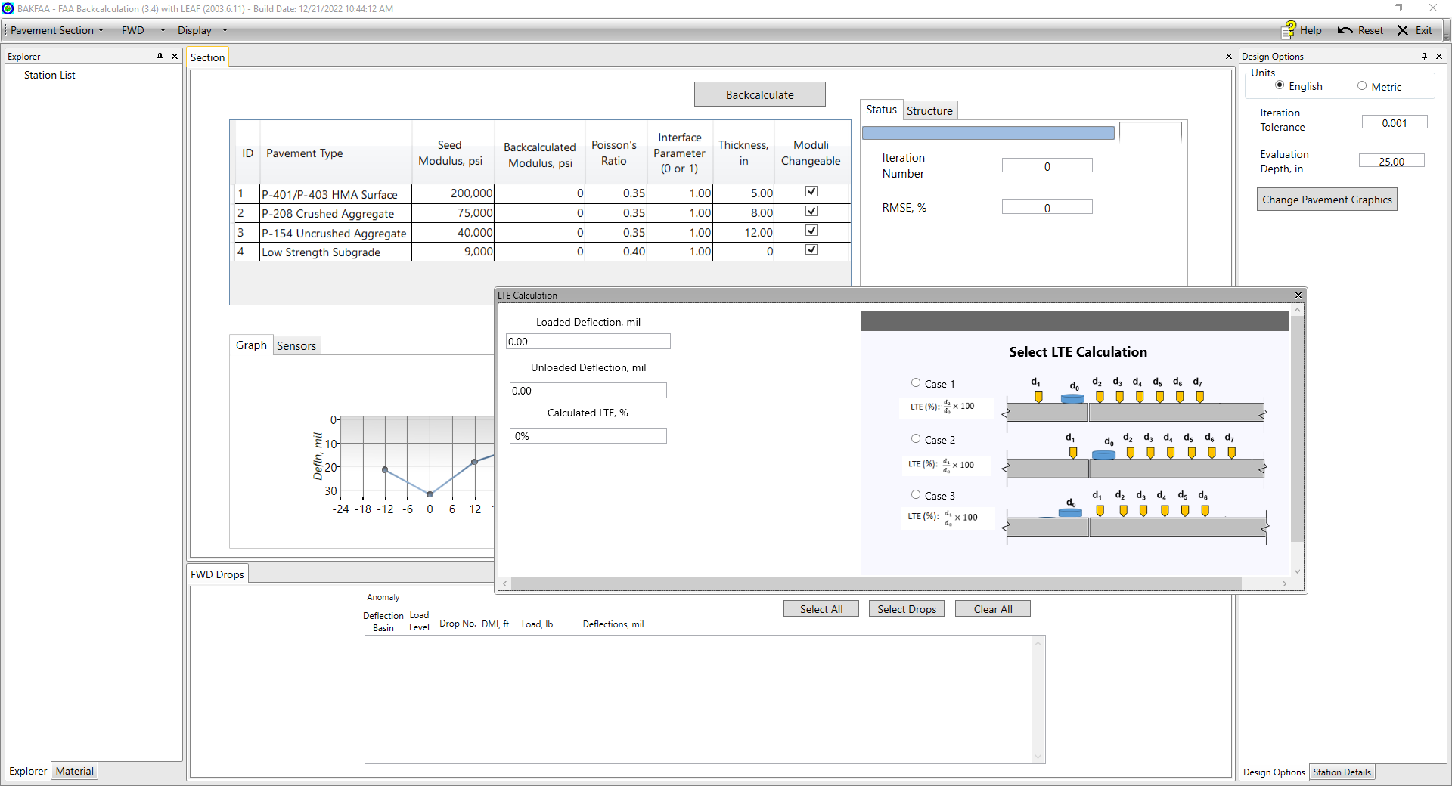
LTE Calculation module has been separated from the main window
as a floating tab
Floating Window
Main Window
Figure 3-2. Interface showing window types and floating tab
Module
FWD Drops is one of the modules in BAKFAA
Module Title
Toolbar
Header
Figure 3-3. Interface showing the header, toolbar, and modules
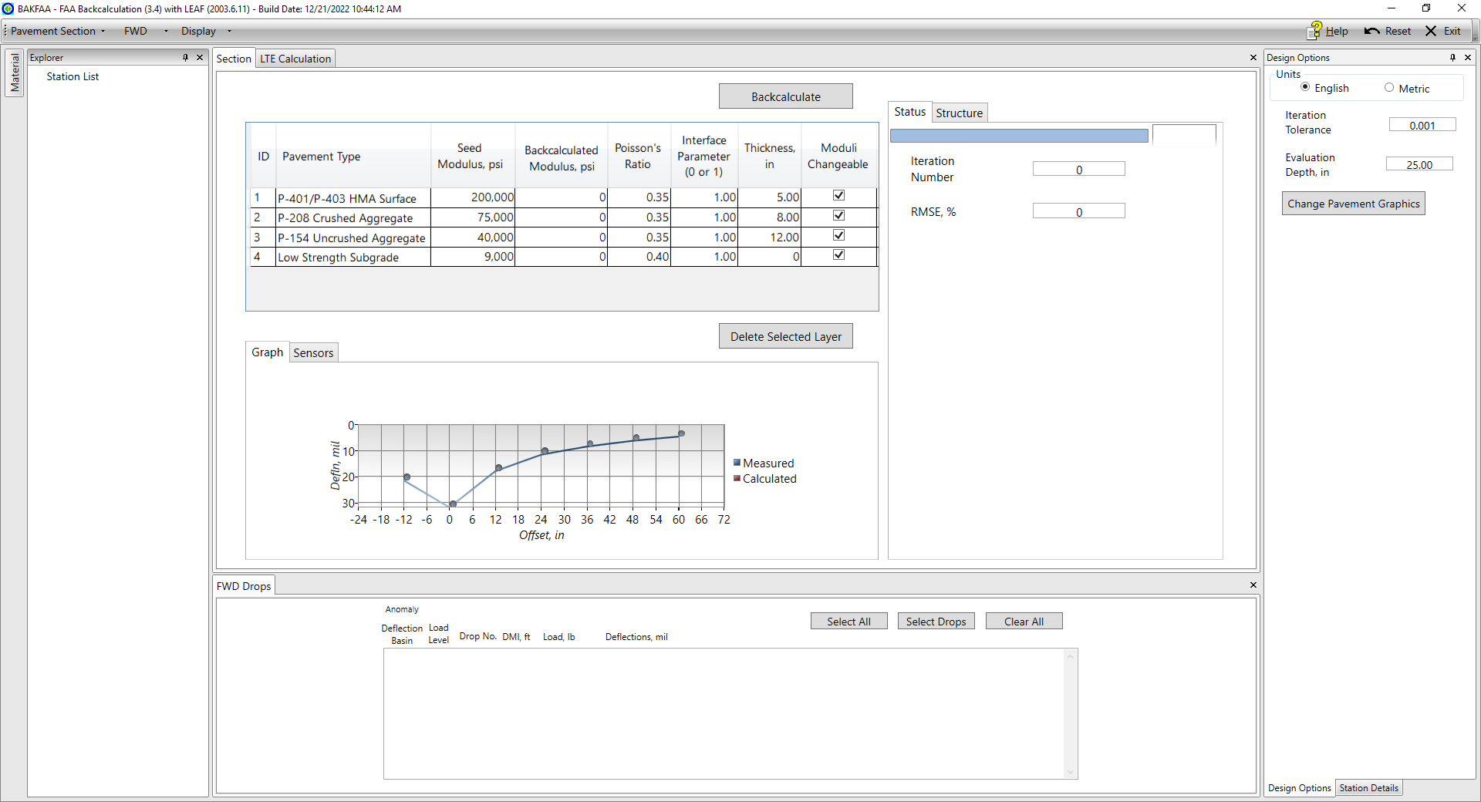
The FWD Drops module is ungrouped
Document (grouped)
Document (ungrouped)
Docked Tab (grouped)
Docked Tab (ungrouped)
Collapsible Tab
The Section and LTE Calculation modules are grouped
Figure 3-4. Interface showing document and tab types, and grouping

Configuring the Modular Interface
To resize a module, click and drag the module border. Other modules will change size to fit as necessary. An example is shown in Figure 3-5 increasing the size of the left-side tab, which causes the centrally located modules to shrink.
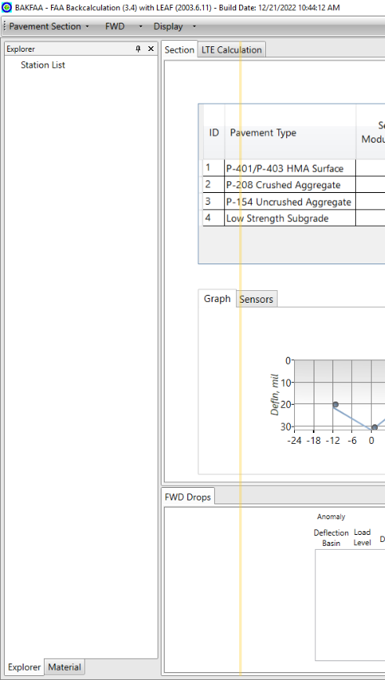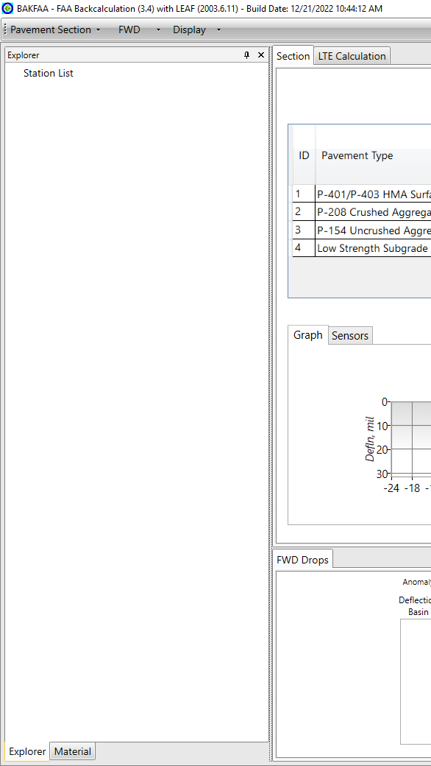
Preview
Figure 3-5. Adjusting interface module size
Modules have several possible position types as defined in Section 3.1.1: an embedded document, a docked tab, a collapsible tab, or a floating tab. All types are adjusted with the same controls. To change the position type of a module, click and drag the module title and move it to the desired location. Hovering over a location will show a preview of the module placement in yellow. Alternatively, the position type of a tab can be change using the drop-down menu in the top-right corner of that tab. In addition, the user can toggle between a docked tab and a collapsed tab using the “pin” button. Modules can be closed by clicking the “X” in the upper right corner, which will remove them from view. To restore closed modules to default view, click the “Reset” button.
When moving a module, there are location markers in each module’s area as shown in Figure 3-6 which correspond to the position types. Dropping a module on the center square adds it to the module group. The arrows around the center square place the module as an adjacent module. Adjacent modules are placed as the same type as the parent module; a module placed from a document will be a document, and the same is true for tabs. Arrows are also available around the edges of the window which will place the module as a tab on that edge. Examples are shown in Figure 3-6 (a) through (d) moving the “Design Options” module from the right side of the GUI (default position) to various locations on the left side. A module can be configured as a floating tab by releasing it anywhere other than on a location marker, as is shown in Figure 3-6 (e).

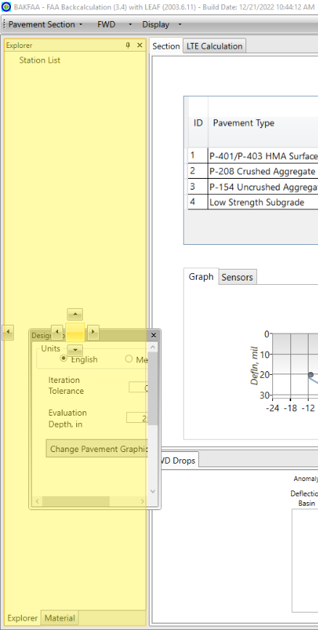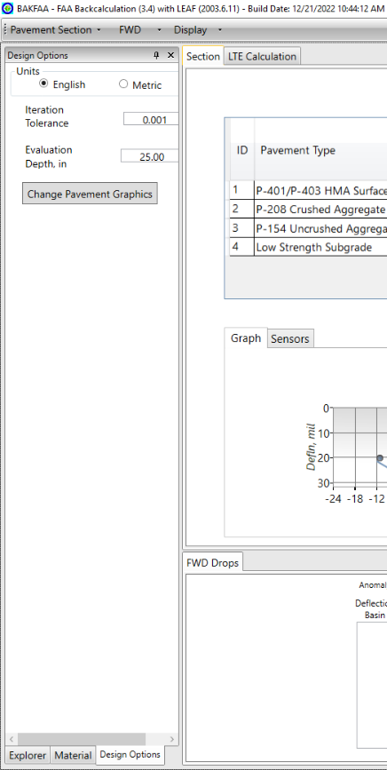
Placement preview
(a) Adding to group of tabs (center square)
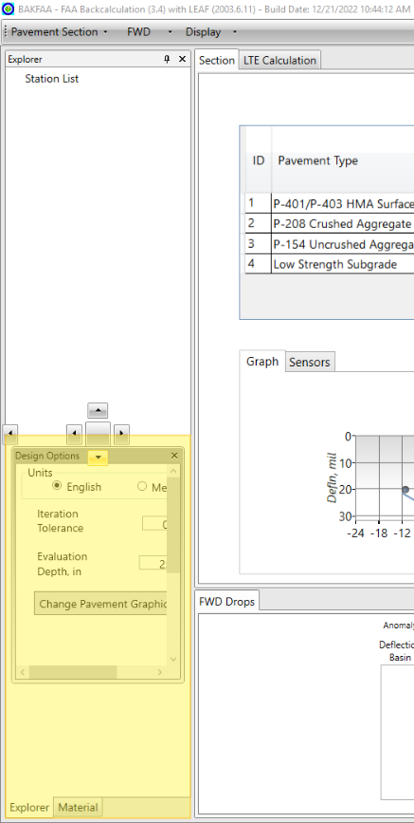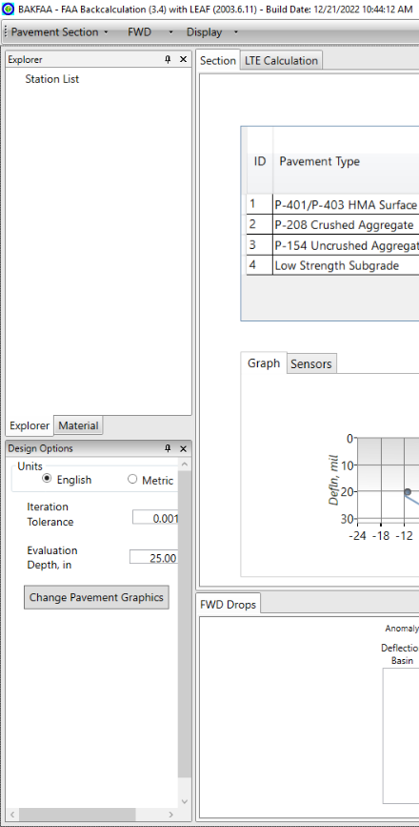
(b) Placing as adjacent tab (surrounding arrows)
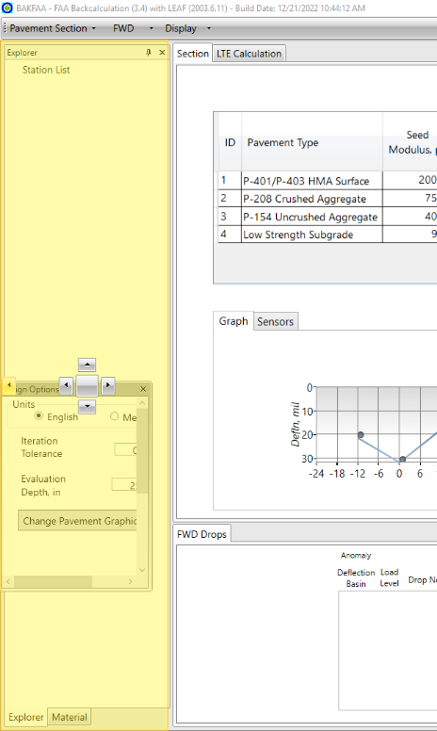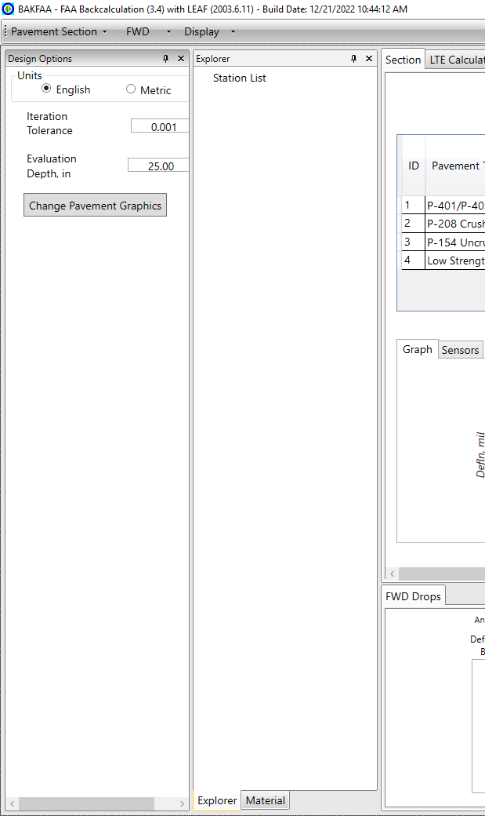
(c) Placing as tab on edge of window (edge arrows)
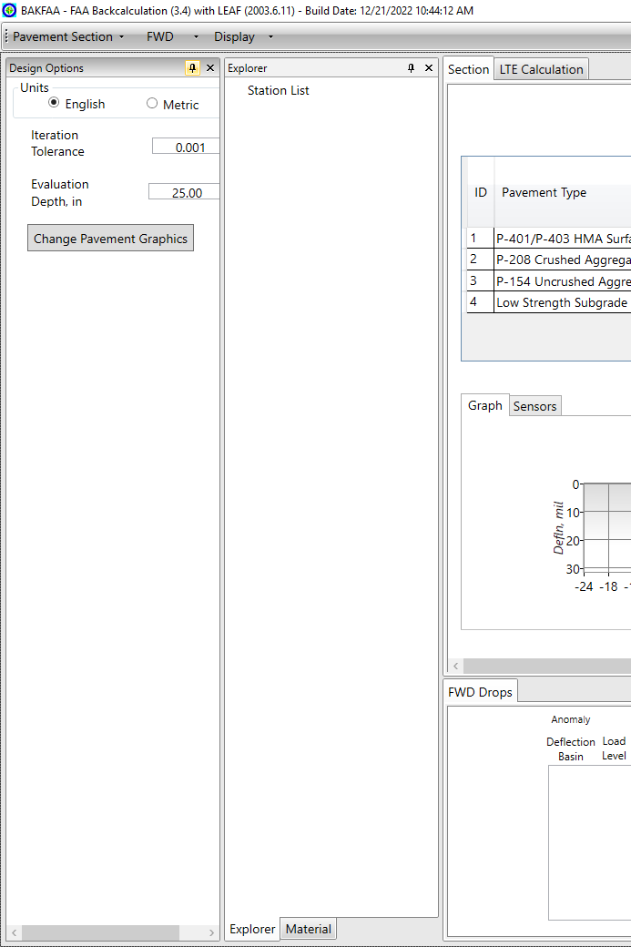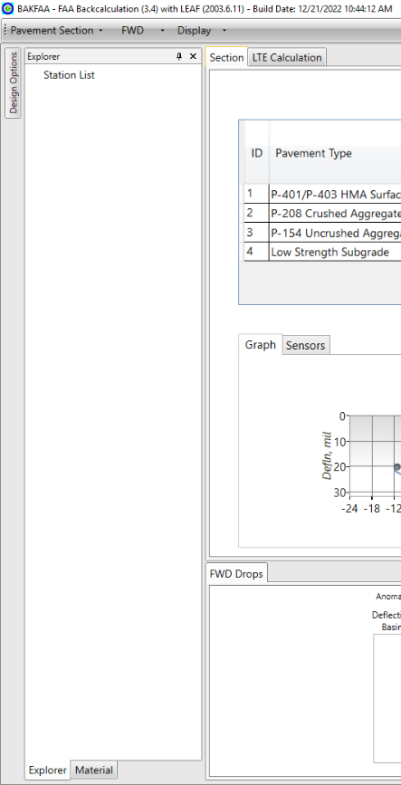
“Pin” button
(d) Collapsing a tab (using the “pin” button)
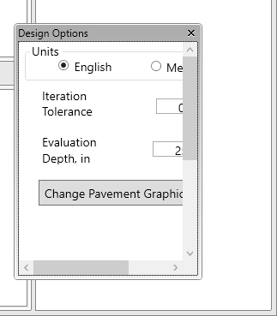
Click and drag
(e) Floating window/tab
Figure 3-6. Positioning a module in the GUI (a) adding to group of tabs (b) placing as adjacent tab (c) placing as tab on edge of window (d) collapsing a tab (e) floating window/tab
The order of modules in a group can be changed by clicking and dragging the titles to the desired order as seen in Figure 3-7.
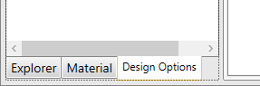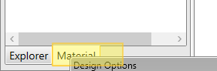
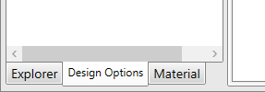
Figure 3-7. Changing title order in module group

BAKFAA Version and FWD File Location
The program header at the top of the window displays the version and build date of BAKFAA that is currently in use, highlighted with a red box in Figure 3-8. After loading an FWD file or .XML file, it displays the location and name of the file. The address is provided for user’s information only. The user cannot change the appearance.
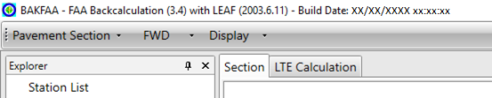
    - Version name (default)
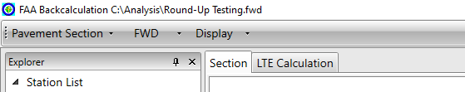
  - After loading file
Figure 3-8. a) Default interface displaying BAKFAA version and b) location/name of the file in use after loading the file

Pavement Layer Structure
The user must define the pavement layer structural information for use in backcalculation and LEAF analysis. The pavement structure is a set of layers with individual thicknesses and material properties that make up the pavement section. Defining the pavement structure requires selecting a number of layers and setting the pavement layer type, seed modulus, Poisson’s ratio, thickness, and the interface parameter for each in the area highlighted with a red box in Figure 3-9. BAKFAA includes a library of pre-defined standard layer materials with default material properties for customizing pavement structures, but also allows the user to define a layer directly with the ‘User Defined’ type. Most of the pre-defined material types correspond to FAA specification items found in AC 150/5370-10H, “Standard Specifications for Construction of Airports”. The library also includes four subgrade types ranging from ultra-low to high strength material. It should be noted that BAKFAA does not distinguish between flexible and rigid pavements. The user must account for this when defining the pavement structure and its layer attributes.
The user can change the pavement layer type from a drop-down menu under the “Pavement Type” column in the “Section” module, as shown in Figure 3-10. The user can add a layer from the drop-down menu under the “Pavement Type” column (see Figure 3-11) which will open the “Layer Property” menu shown in Figure 3-12. The material and position in the structure relative to the selected layer must be chosen. Alternatively, the user can drag and drop material names from the “Material” module to add layers to the structure. The user can delete a layer using the “Delete Selected Layer” button as illustrated in Figure 3-11. The minimum number of layers is three and the maximum is six. Most layer types can be placed at any position in the pavement structure, with the exception of a subgrade layer which can only be set as the bottom of the structure. The user must assign pavement structure properties for each layer. BAKFAA will provide a warning “Non-numerical values are not acceptable” if any of the property boxes are left blank. Regardless of the layer type assigned to the last layer in the pavement structure, BAKFAA treats the last layer as a semi-infinite layer and assigns 0 for the thickness.
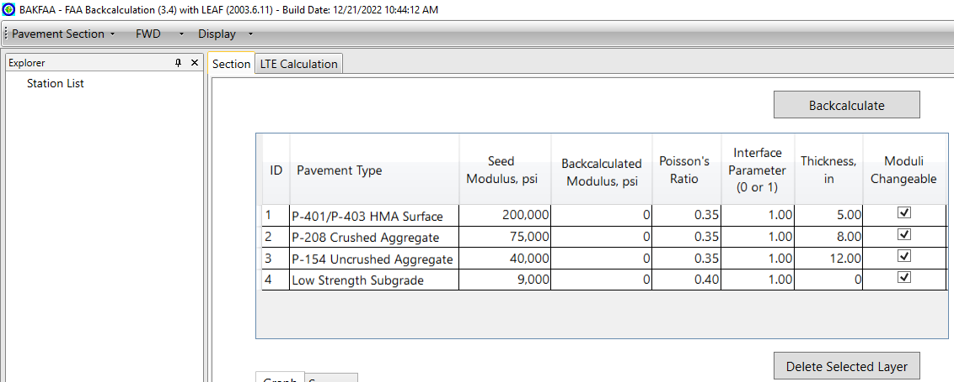
Figure 3-9. Defining pavement structure in BAKFAA
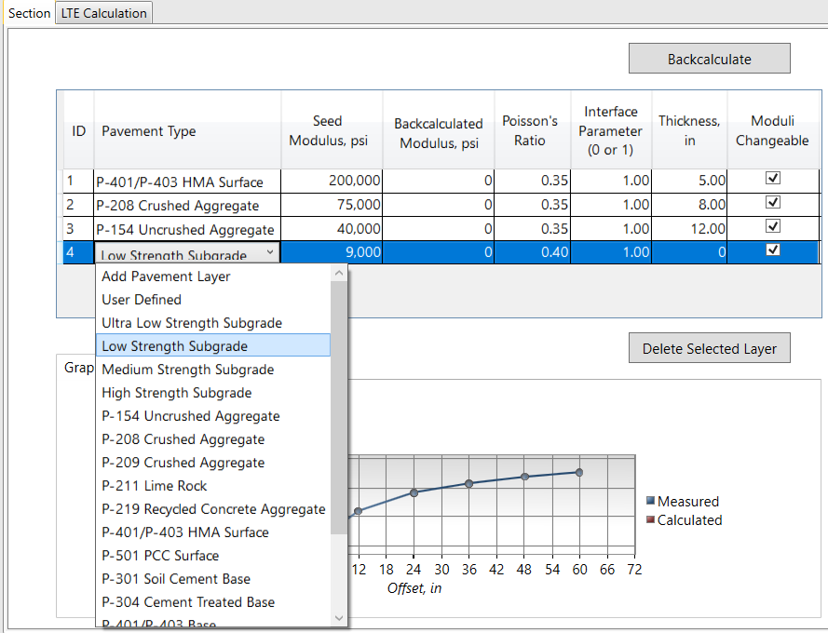
Select standard or User Defined pavement layer
Figure 3-10. Selecting pavement type in BAKFAA
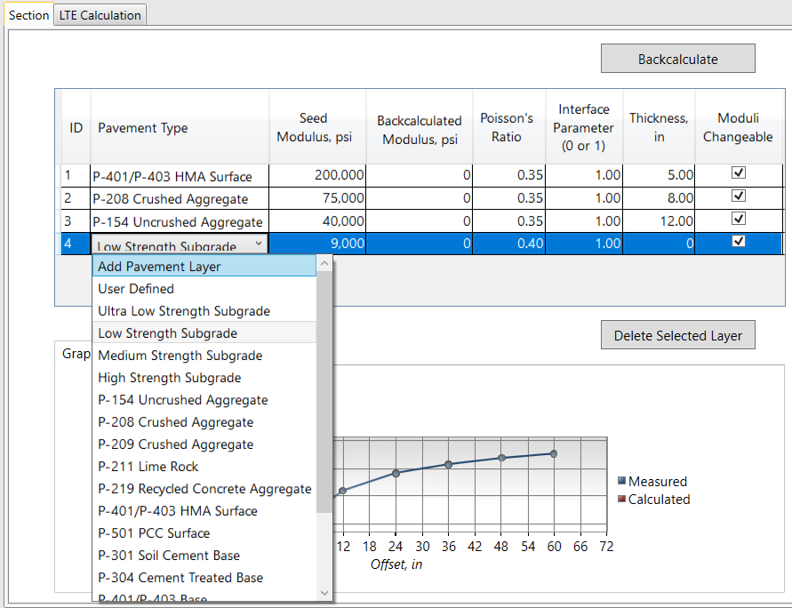
Delete a pavement layer
Add a pavement layer
Figure 3-11. Adding or deleting a pavement layer in BAKFAA
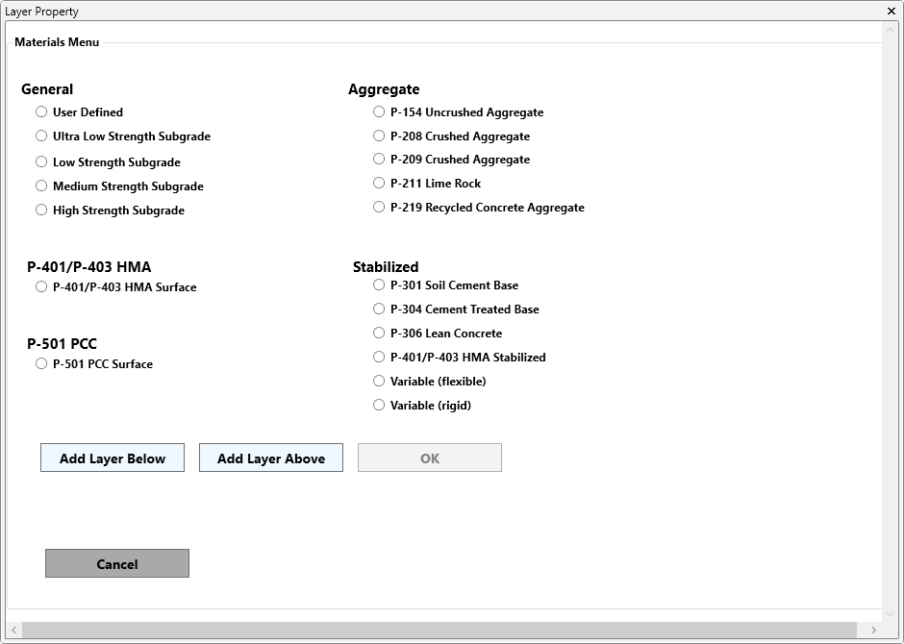
Figure 3-12. Layer Property menu used to add a pavement layer
To supplement the pavement layer table, the structure is also depicted in a graphical format as a pavement cross section in the “Structure” submodule as seen in Figure 3-13. It presents the material type as well as the thickness and seed modulus for each layer. Graphics are applied according to the general type of material. The user can toggle between hatched (default) graphics and photorealistic graphics with the “Change Pavement Graphics” button in the “Design Options” module. Layer thicknesses are reflected proportionally in the figure, with the infinite bottom layer displayed as 12 inches (305 mm) thick. Clicking on a pavement layer opens the “Layer Property” menu (see Figure 3-12) which can be used to change the material or add a pavement layer.
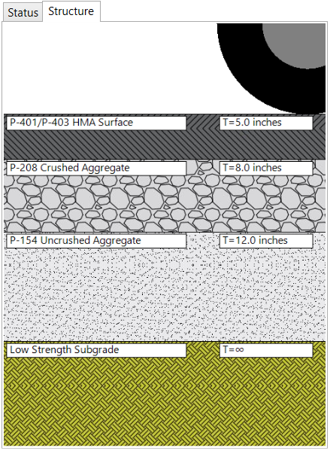
Figure 3-13. Pavement structure submodule

Seed Modulus
BAKFAA requires a seed modulus value for each pavement layer. Seed moduli are initial modulus values used in the backcalculation iterative procedure. The pre-defined materials have default seed values, but these can be edited by the user to any value greater than zero. BAKFAA will provide a warning if the user inputs zero or a negative value. If the user edits the seed modulus value, BAKFAA will automatically reclassify the material as ‘User Defined’. Seed modulus values are generally assigned based on the best information available from the material properties, such as historic data, material aging, level of damage to each layer, temperature of asphalt concrete, and moisture or freezing conditions of the unbound material. Other laboratory or nondestructive testing data can also be used to estimate seed modulus values.
Table 3-1 provides typical modulus values and ranges for paving materials based on FAA Advisory Circular 150/5370-11B, “Use of Nondestructive Testing in the Evaluation of Airport Pavements”. Table 3-2 presents default seed modulus values for pavement layers in BAKFAA.
Table 3-1. Typical modulus values and ranges for paving material
Material | Item Number | Low Value |  | Typical Value |  | High Value
Material | Item Number | psi | MPa | psi | MPa | psi | MPa
Asphalt Mix Pavement | P-401/P-403 | 70,000 | 500 | 500,000 | 3,500 | 2,000,000 | 14,000
Cement Concrete Pavement | P-501 | 1,000,000 | 7,000 | 5,000,000 | 35,000 | 9,000,000 | 60,000
Lean Concrete Base Course | P-306 | 1,000,000 | 7,000 | 2,000,000 | 14,000 | 3,000,000 | 20,000
Asphalt Treated Base |  | 100,000 | 700 | 500,000 | 3,500 | 1,500,000 | 10,000
Cement Treated Base | P-304 | 200,000 | 1,400 | 750,000 | 5,000 | 2,000,000 | 14,000
Aggregate Base Course | P-208/P-209 | 10,000 | 70 | 30,000 | 200 | 50,000 | 350
Granular Subbase Course | P-154 | 5,000 | 30 | 15,000 | 100 | 30,000 | 200
Stabilized Soil |  | 10,000 | 70 | 50,000 | 350 | 200,000 | 1,400
Cohesive Soil |  | 3,000 | 20 | 7,000 | 50 | 25,000 | 170

Backcalculated Modulus
The “Backcalculated Modulus” column displays the backcalculated modulus value for each pavement layer following the completion of backcalculation analysis. If the user selects a single FWD drop and runs backcalculation, the “Backcalculated Modulus” column will include the result of the backcalculation for that single selected drop. If the user selects multiple FWD drops and runs backcalculation, the geometric mean (written as ‘Geo. Mean’) of the backcalculated layer modulus values for the selected drops will be displayed.

Poisson’s Ratio
BAKFAA requires a Poisson’s ratio for each pavement layer. While the pre-defined standard materials have default values, they and those of user defined materials can be assigned to any numerical value between 0 and 0.5 by clicking on the cell and inputting a new value. The default Poisson’s ratio values for pre-defined materials available in BAKFAA are presented in Table 3-2.

Table 3-2. Default seed modulus and Poisson’s ratio values for pavement layers in BAKFAA
No. | Material | Item Number | Default Seed Modulus |  | Default Poisson's Ratio
No. | Material | Item Number | psi | MPa | Default Poisson's Ratio
1 | Ultra-Low Strength Subgrade |  | 5,000 | 35 | 0.40
2 | Low Strength Subgrade |  | 9,000 | 60 | 0.40
3 | Medium Strength Subgrade |  | 15,000 | 100 | 0.40
4 | High Strength Subgrade |  | 20,000 | 140 | 0.40
5 | Granular Subbase Course | P-154 | 40,000 | 275 | 0.35
6 | Aggregate Base Course | P-208 | 75,000 | 515 | 0.35
7 | Crushed Aggregate Base Course | P-209 | 75,000 | 515 | 0.35
8 | Lime Rock Base Course | P-211 | 60,000 | 410 | 0.35
9 | Recycled Concrete Aggregate Base Course | P-219 | 75,000 | 515 | 0.35
10 | Soil Cement Base | P-301 | 250,000 | 1,720 | 0.20
11 | Cement Treated Aggregate Base Course | P-304 | 500,000 | 3,445 | 0.20
12 | Asphalt Mix Pavement Surface Course | P-401 | 200,000 | 1,375 | 0.35
13 | Asphalt Mix Pavement Base Course | P-403 | 400,000 | 2,755 | 0.35
14 | Cement Concrete Pavement | P-501 | 4,000,000 | 27,560 | 0.15

Interface Parameter
The Interface Parameter represents the bonding condition between two pavement layers and has a value of 0 or 1, with 0 indicating no bond and 1 indicating fully bonded layers. The default value for the interface parameter is 1 in BAKFAA since complete bonding between pavement layers is commonly the case in pavement structures. However, the user should assign 0 to the interface parameter where no bonding exists between adjacent pavement layers, such as with a concrete slab on top of an asphalt layer.

Pavement Layer Thicknesses
BAKFAA requires a thickness for each pavement layer. BAKFAA treats the last layer as a semi-infinite layer, so its thickness must be zero. Zero is not an accepted thickness for other layers.

Moduli Changeable
The “Moduli Changeable” checkbox allows the user to determine whether a layer’s modulus will be calculated in the backcalculation analysis or treated as a fixed value based on the assigned seed modulus. The checkbox is toggled on for all layers by default. If the “Moduli Changeable” checkbox is checked, the layer modulus will be calculated during the backcalculation. If it is not, modulus value will be fixed to the assigned seed modulus value and will not change during the iteration process. The backcalculated layer modulus will be the same as the seed modulus.

Saving and Loading Pavement Section
The user can save a defined pavement structure for later use by clicking “Pavement Section” on the top toolbar and selecting “Save Pavement Section” as highlighted in Figure 3-14. If an FWD file is not loaded, the pavement structure will be saved in an .XML file format. If an FWD file is loaded, BAKFAA will provide a popup box and ask if the user wants to save the FWD deflection data along with the pavement structure data. Click the “Yes” button to save both FWD and pavement structure data. Click the “No” button to only save the pavement structure data. The user will be asked to provide a file path to save the .XML file.
The user can load any saved pavement section by clicking the “Pavement Section” drop-down from the toolbar and selecting “Load Pavement Section”. If the saved XML file contains only the pavement structure data, only the pavement structure data will be loaded and the user will be required to load an FWD file separately. If the saved .XML file contains both the pavement structure and FWD data, both data types will be loaded to the BAKFAA interface.
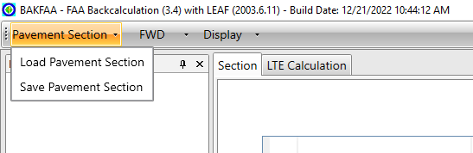
Load a pavement section
or a pavement and FWD file
Save a pavement section
or a pavement and FWD file
Figure 3-14. Saving and loading pavement sections
A pavement structure file consists of .XML tags. There are two sections in the file: “BasinList” and “Structures”. The “BasinList” section contains the tags associated with the FWD tests. This includes FWD drops, sensor offsets, and recorded deflections for each FWD drop. The “Structures” section contains tags associated with each pavement layer, including layer thickness, seed modulus, Poisson’s ratio, interface parameter, and moduli changeable values. Figure 3-15 presents an example of a “BasinList” section and a “Structures” section of the .XML file.

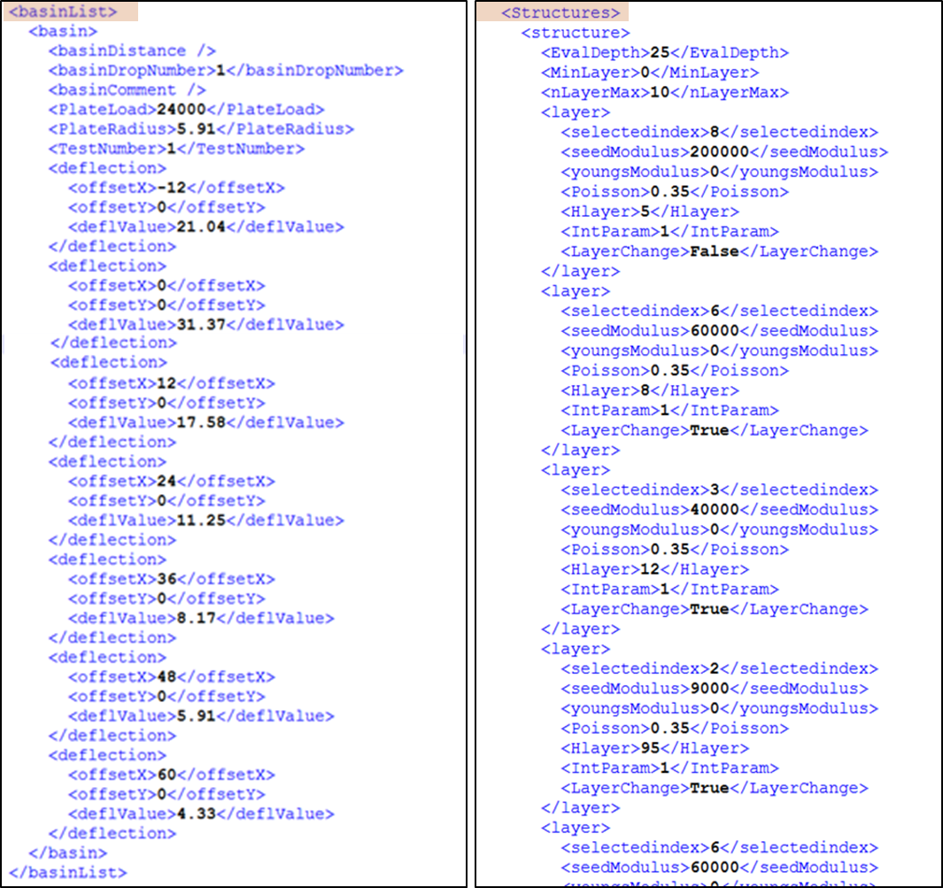
Figure 3-15. Example of pavement section .XML file containing FWD test and pavement structure data

Units
Throughout the BAKFAA program, the values of items can be displayed in either English or metric units by selecting the appropriate radio button under the “Design Options” module as highlighted in Figure 3-16. The default unit setting is English (US Customary). Changing the unit will automatically update the units of all FWD and pavement information as shown in Figure 3-17 through Figure 3-20. The output files will also conform to the user’s unit selection.
Table 3-3 lists the English and metric units used for different items in the BAKFAA GUI and output files.

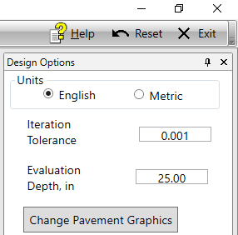
Figure 3-16. Selection of Units

Table 3-3. English and Metric units used for illustration of different entities in BAKFAA
Entity | Unit
Entity | English | Metric
Pavement Layer Thickness | Inch (in.) | Millimeter (mm)
Distance | Feet (ft.) | Meter (m)
FWD Sensor Offset | Inch (in.) | Millimeter (mm)
FWD Sensor Deflection | Mil | Micron (mc)
FWD Plate Radius | Inch (in.) | Millimeter (mm)
FWD Plate Contact Area | Square inch (in²) | Square millimeter (mm²)
FWD Plate Contact Pressure | Pound per square inch (psi) | Megapascal (MPa)
Load | Pound (lbs.) | Kilonewton (kN)
Modulus | Pound per square inch (psi) | Megapascal (MPa)

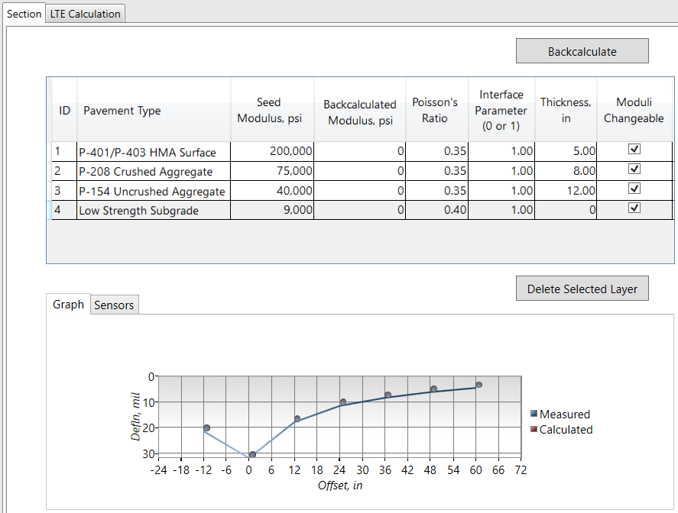
Deflection Graph
(a) deflection graph
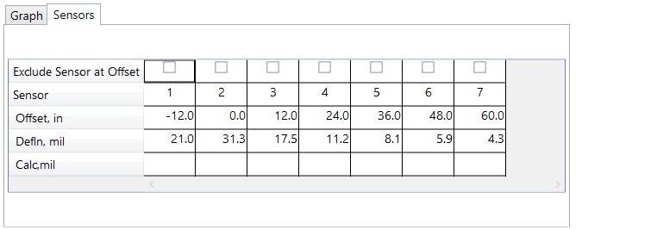
Default number of sensors
Default measured deflections
Default sensor offsets
Sensor Table
(b) sensor table
Figure 3-17. Default FWD test setup shown in English units
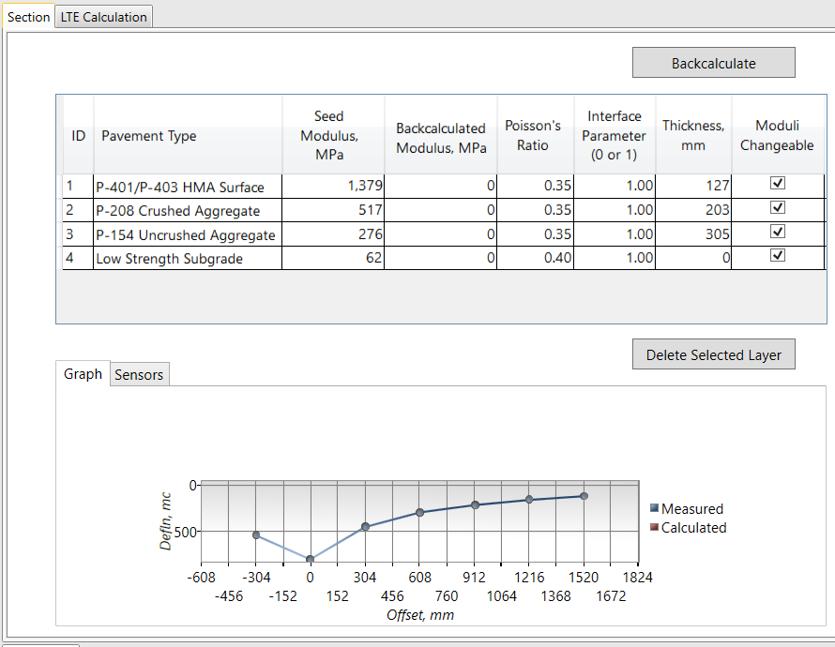
(a) deflection graph
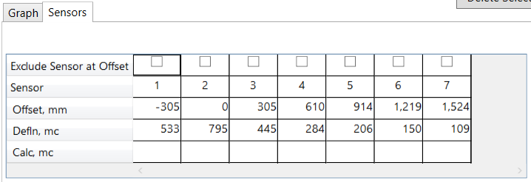
(b) sensor table
Figure 3-18. Default FWD test setup shown in Metric units
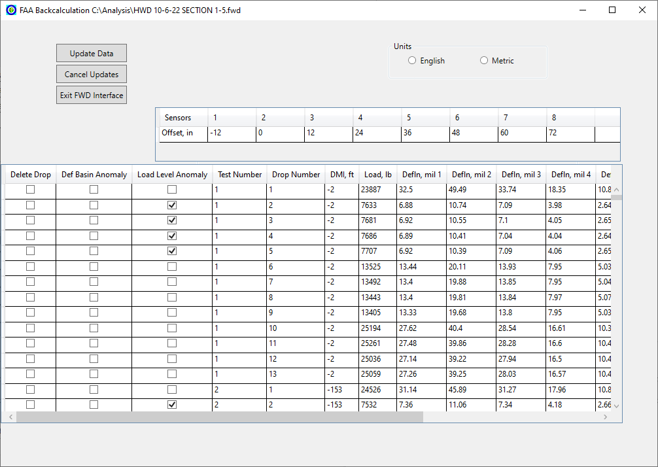
Figure 3-19. FWD file sub-window shown in English units
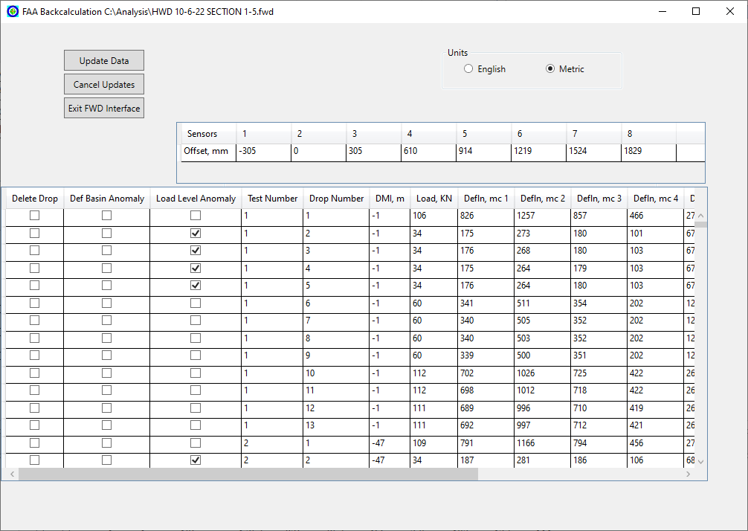
Figure 3-20. FWD file sub-window shown in Metric units

FWD Test Information
BAKFAA’s “Section” module provides a deflection graph and a sensor table that display FWD information, as highlighted in Figure 3-21 (a) and (b) respectively. The sensor table includes FWD sensor number, sensor offset, and measured deflection at each sensor (from the FWD file data). The graph and table also include calculated deflections at each sensor from the BAKFAA analysis, which will update after the backcalculation is completed. The values in the deflection table are not editable.
The “Exclude Sensor at Offset” row in the sensor table allows the user to exclude any of the sensors from the backcalculation analysis by clicking the checkmark box. BAKFAA will provide a popup message warning indicating that to regain the excluded sensor, the user must reload the original FWD or pavement structure .XML file (see Figure 3-22).
When the BAKFAA software is opened, a default FWD test setup with placeholder values is displayed. After the user loads a file, the values will update based on the information in the file. The deflection graph displays a plot of both measured and calculated deflections. Figure 3-23 (a) and (b) show the calculated deflections and updated deflection graph after completion of the backcalculation. This example uses the default deflection basin and pavement structure settings and excludes the sensor at the -12-inch offset.
Deflection Graph
(a) Deflection graph
Default number of sensors
Default measured deflections
Default sensor offsets
Sensor Table
(b) Sensor table
Figure 3-21. Default FWD test setup
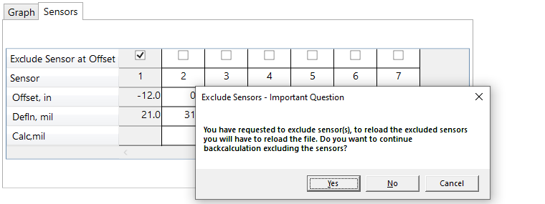
Exclude sensor at -12-inch offset
Figure 3-22. Exclusion of sensor warning

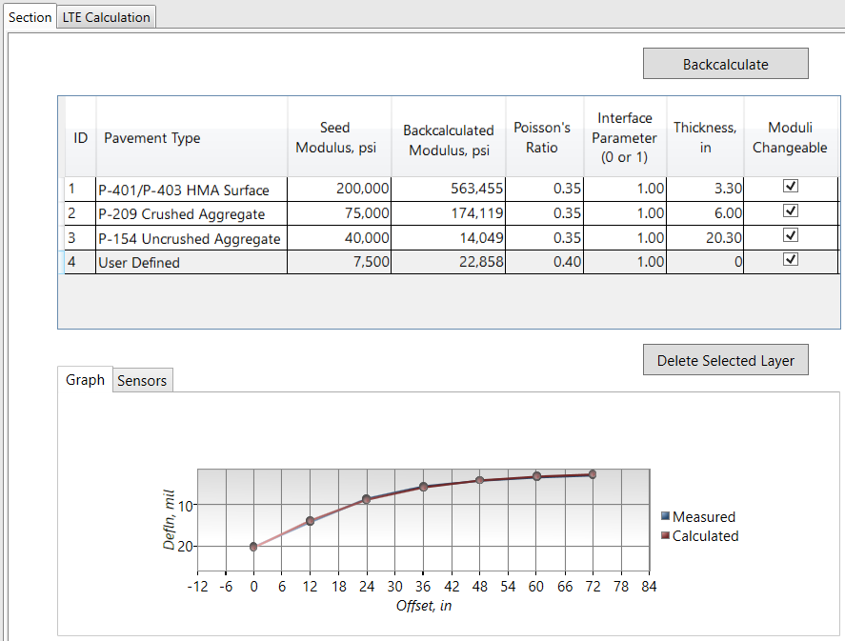
Deflection graph updates during backcalculation procedure
(a) Deflection graph
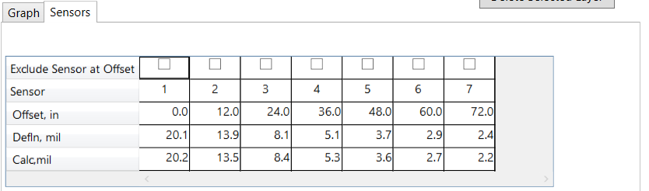
Calculated deflections
(b) Sensor table
Figure 3-23. Calculated deflections and updated deflection graph after backcalculation analysis

Load FWD Files
Several manufacturers produce FWD devices and each device uses a unique FWD file format. BAKFAA can process proprietary file formats used by some of the leading FWD manufacturers, including Dynatest, KUAB, Foundation Mechanics (JILS division), Pavetest, and CarlBro. Table 3-4 lists all the file types supported by the current version of BAKFAA.

Table 3-4. File types supported by BAKFAA
Equipment Manufacturer | Associated Data Format | File Extensions
Dynatest | R80, R32 | .fwd, .hwd
Dynatest | F20, F25 | .fwd, .F20, .F25
Dynatest | PDDX, XML | .ddx, .xml
KUAB | KUAB | .fwd, .hwd
JILS | M3, M5 | .fwd, .hwd, .dat
PaveTest | PaveTest | .csv
CarlBro | CarlBro | .fwd, .txt
AASHTO | Pavement Deflection Data Exchange | .ddx
BAKFAA allows the user to import an FWD file directly into the interface by clicking the “FWD” drop-down in the top toolbar then “Load FWD File”, and then browsing to select an FWD file (see Figure 3-24 (a)).
The FWD file information for each FWD drop including measured deflections, FWD plate load, distance measuring instrument (DMI) location information, drop number, and anomaly checks will be displayed in the “FWD Drops” module, as highlighted by a red box in Figure 3-24.
- Anomaly check boxes allow quality control of FWD data. FWD drops are flagged if anomalies are identified in load levels or deflection basins.
  - Deflection basins are flagged if the recorded deflections are 1) showing a non-decreasing sequence, 2) larger than 100 mils (2540 mc), or 3) recorded zero. Deflections larger than 100 mils are flagged because they are beyond the linear range of most deflection sensors.
  - Load levels are flagged if the recorded FWD plate load is smaller than 9,900 lbs. or larger than 60,024 lbs. (44 kN – 267 kN).
- “Drop No.” is the number of FWD drops in a single FWD test. BAKFAA has no limitations on the maximum number of drops in a single FWD test. Test locations can have a different amount of drop numbers.
- “DMI” identifies the location (also known as ‘station’) of each FWD test point.
- “Load” displays the applied FWD load for each drop.
- “Deflections” are measured deflections recorded by the FWD sensors for each drop.
- The operator comments for test locations are identified by BAKFAA and replaced with a ‘Station’ number, starting at 1 and increasing sequentially.
The “Station Details” module displays the FWD drop information including measured deflections, FWD plate load, DMI location information, drop number, and anomaly checks for all drops in the station of the selected drop (see Figure 3-25). The values in “Station Details” are not editable.
The deflection graph and sensor table update when the user selects an FWD drop (see Figure 3-24 (b)).
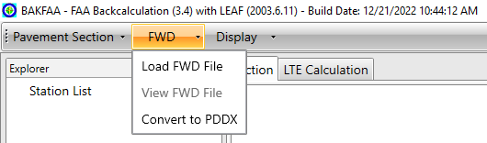
Load FWD file
View FWD file
(a) Loading a FWD file
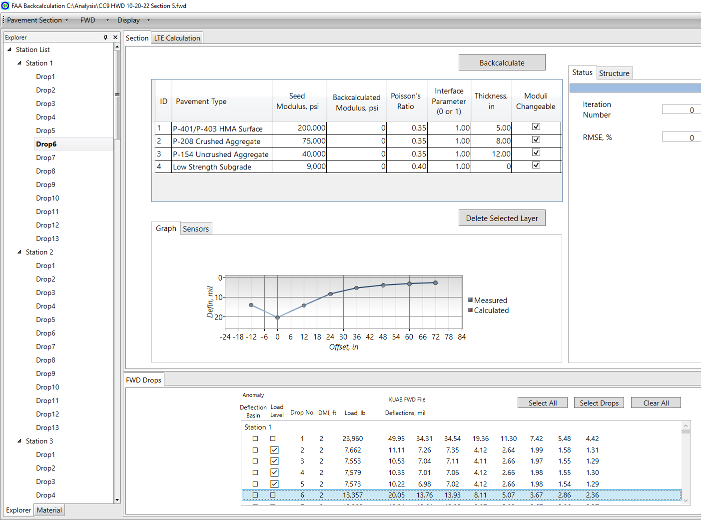
(b) Selecting a drop
Figure 3-24. (a) Loading a FWD file and (b) Selecting a drop
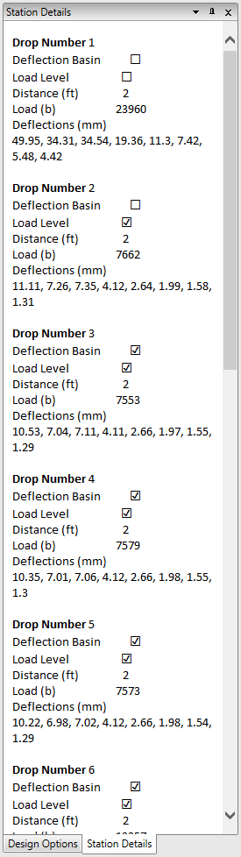
Figure 3-25. Viewing details of an FWD station

View FWD File
BAKFAA allows the user to view and edit a loaded FWD file by clicking the “FWD” drop-down in the top toolbar then “View FWD File” (see Figure 3-24). Figure 3-26 shows the FWD file sub-window for a sample FWD file. This sub-window is interactive, allowing the user to switch units or edit the FWD information. Click the “Update Data” button to save the changes and click the “Exit FWD Interface” button to return to the main window. Any changes made to the FWD file will be reflected in the “FWD Drops” module. This will not alter the original FWD file, however the user can save the modified FWD file as a new .XML file by clicking on the “Pavement Section” drop-down in the top ribbon then “Save Pavement Section”.
Figure 3-26. FWD file sub-window

Convert FWD File to PDDX Format
The user can convert any FWD file format supported by BAKFAA to the Pavement Deflection Data Exchange (PDDX) format by clicking on the “FWD” drop-down in the top toolbar then “Convert to PDDX” and browse to provide a save path for the file. The PDDX files can be loaded to the program by clicking on the “FWD” drop-down then “Load FWD File”.
Pavement deflection data files are typically structured using American Standard Code for Information Interchange (ASCII) columnar or tagged formats. Processing the deflection data in ASCII format requires a device-specific procedure for each manufacturer’s FWD device. The PDDX format is intended to address the shortcomings of dealing with multiple file formats and to facilitate easy access and data exchange capabilities for all FWD data formats. The PDDX format includes data storage in ASCII format, similar to the deflection data format used by FWD manufacturers. The ASCII file type allows the user to easily edit and organize data files using a standard text editor. However, the PDDX file format specification has a modular structure in which data elements of similar characteristics are grouped in sections. The first line of each section contains a data description demarcated with brackets. Each section contains several variables with their associated values. Below is an example of the general format of this modular approach (AASHTO 1998):
[Section 1]
Entry1 = Value (s)
Entry2 = Value (s)
Entry2 = Value (s)
[Section 2]
Entry4 = Value (s)
Entry5 = Value (s)
Entry6 = Value (s)
The PDDX format allows for more flexibility in terms of the amount of data that can be stored and can accommodate future additional data elements that may be collected by FWD devices (AASHTO 1998). Further information about PDDX file formats can be found in the technical guide for PDDX format (version 1.0) published by the American Association of State Highway and Transportation Officials (AASHTO).

FWD File Parser
BAKFAA’s file processing class that reads FWD files uses the file format specifications from FWD manufacturers and generates a set of properties to retrieve data required for functions in the backcalculation and LEAF analysis. The manufacturers’ FWD file formats are not hard coded into the file processing class, instead the file processing class reads the data format specifications from the data source and processes the file based on the specifications. The advantage of this design is that when a new data format is introduced by a manufacturer, only a file specification needs to be created for the new layout. In this case, BAKFAA will read the specification and parse the file without requiring any reprograming in the source code.
The process uses a file specification in .XML format to determine how to read the content of data files. The file specification must provide the key information required for BAKFAA. Spec files should specify “Header” data and “Test” data. Header data is specific to the file. Test data will contain information from each test location and each FWD drop. The parser works by comparing each line in a data file against patterns specified in the .XML file. There are two main modes of operation, identified by the <SplitType> tag: delimited (D) and fixed width (F).
In the delimited mode, the software searches each line for the value of the <Line> tag. If it finds a match, it breaks the line into fields by splitting it based on the contents of the <Delim> tag. It then stores the value in the field number identified by the <Pos> tag and stores it in the variable identified by the <Name> tag. Field numbers are zero-based, that is, the first field in a line is field number 0. An example of a delimited data element (FWD file) and the required code for extracting specific data from the file is provided in Figure 3-27. This example illustrates the extraction of the FWD software edition “programVersion” from a Dynatest F25 file. This information is found in the second field (position 1) on a line that starts with “5001” and is delimited by commas (SplitType “D”). In this example, “programVersion” has the value of “25.60” in the first line.
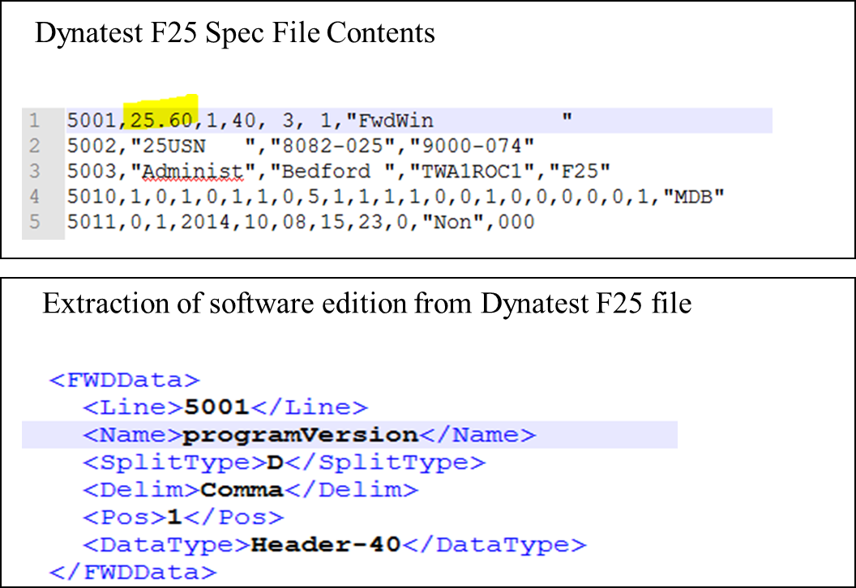
Figure 3-27. Example of delimited data file and the extraction of software edition
In the fixed-width mode, when the software finds a match to <Line> a tag, it extracts a value <Delim> characters long starting at line position <Pos>. The value is stored in the variable identified by the <Name> tag. Character positions are also zero-based. The example provided in Figure 3-28 finds the same information, “programVersion” in a Dynatest R32 file, which is a fixed-width format file.
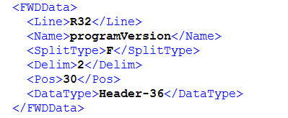
Figure 3-28. Extraction of software edition from Dynatest R32 file with fixed-width format
The parser has the ability to perform a two-level split. It extracts a string as described above, and then splits the extracted value according to the <SplitType2>, <Delim2>, and <Pos2> tags before storing in the variable identified by the <Name> tag. It is possible to have different types of splits (delimited or fixed-width) for the first and second levels. An example of a two-level split is provided in Figure 3-29. In KUAB files, extracting the day, month, and year of the file requires a two-level split. The line containing the date starts with “IDate Created”. The information data is delimited from the label by a “:” (colon). The date “4/26/2013” is after the colon, meaning it is in position 1. The label “IDate Created” is position 0 because numbering is zero based. In the 2nd level, The parser splits the date “4/26/2013” into day, month, and year, and store the values in fileDay, fileMonth, fileYear, respectively. The date is delimited by “/” (forward slash), as such <SplitType2> is D (delimited). The day is in position 0, the month is in position 1, and the year is in position 2.
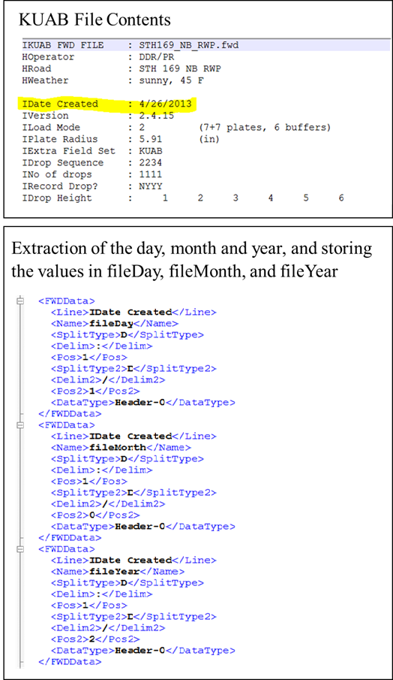
Figure 3-29. Example a two-level split extraction
There are two sections at the top of the .XML files: “Translate” and “AssignedData.” Translate is used to convert proprietary values and flags to the standard values used by BAKFAA. For instance, CarlBro uses the value “Metric” or “English” to indicate the units for the test location station. The translate tag converts these values to “m” or “ft”, the values used internally by BAKFAA, as shown in Figure 3-30. Translate has three XML tags: Name, InValue, and OutValue. When the value of unitsDistance in the file is “English”, BAKFAA changes the value to “ft” before storing it internally.
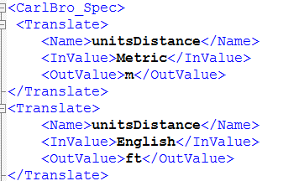
Figure 3-30. Example of functionality of “Translate” section of the XML file
The “AssignedData” section of the spec file is used to provide information to BAKFAA that is not available in the data file. For example, CarlBro files always store values in Metric units and therefore do not store the unit type in the data file itself. This information must be provided in the “AssignedData” section using the <Name> and <Value> tags as provided in Figure 3-31.
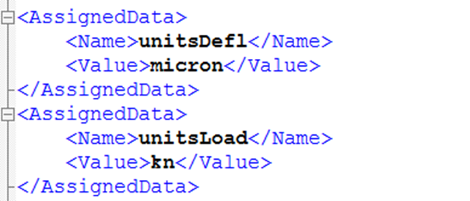
Figure 3-31. Example of functionality of “AssignedData” section of the XML file
For KUAB and CarlBro, the Spec files are specific to the number of sensors on the device. For these types of files, BAKFAA first counts the number of sensors and selects the Spec file for the number of sensors. Table 3-5 lists the specifications available for the KUAB and CarlBro files.

Table 3-5. Available specifications for KUAB and CarlBro file types
Manufacturer | Available Specs
KUAB | KUAB_Spec_7_Sensors.xml
KUAB | KUAB_Spec_8_Sensors.xml
KUAB | KUAB_Spec_9_Sensors.xml
CarlBro | CarlBro_Spec_4_Sensors.xml
CarlBro | CarlBro_Spec_9_Sensors.xml
CarlBro | CarlBro_Spec_17_Sensors.xml
Users can change the number of sensors in these files by copying an existing file and adding or removing tags that identify sensor information, such as:
- sensorDeflY
- sensorDeflX
- dropDeflections
Required values are:
- sensorDeflY (1 for each sensor)
- sensorDeflX (1 for each sensor)
- dropDeflections (1 for each sensor)
- unitsPlateRadius
- unitsLoad
- unitsDefl
- unitsOffset
- unitsDistance
- equipmentPlateRadius
- locationDistance
- dropLoad

Selection of FWD Drops for Backcalculation
There are three ways to select FWD drops for backcalculation analysis:
- Selecting single or multiple FWD drops. The user can select a single FWD drop by clicking on any drop in the “FWD Drops” or “Explorer” modules. The FWD drop will be selected and the user can run backcalculation for the single selected drop. In the “FWD Drops” module, the user can select multiple consecutive drops by holding ‘Shift’ then clicking on the first and last drops or can select multiple distinct drops by holding ‘Ctrl’ then clicking on the desired drops (see Figure 3-32).
- Selecting all drops by clicking the “Select All” button in the “FWD Drops” module shown in Figure 3-32.
- Selecting specific drop number(s) by clicking the “Select Drops” button in the “FWD Drops” module. Select the desired drop numbers (drop No.1, No.2, etc.) from the “Drop No.” menu, as shown in Figure 3-33. For example, by selecting drop number 2 from the menu, the second FWD drop for each test location will be selected.
Clicking the “Clear All” button in the “FWD Drops” module (Figure 3-32) will clear any and all FWD drop selections.
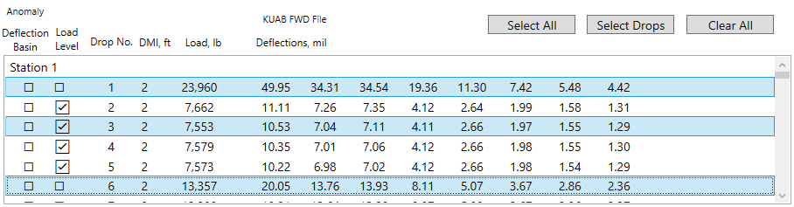
Select all drops
Click on FWD drops to select
Select drop numbers
Clear selection
Figure 3-32. FWD drop selection in the “FWD Drops” module and the “Select Drops”, “Select All”, and “Clear All” buttons
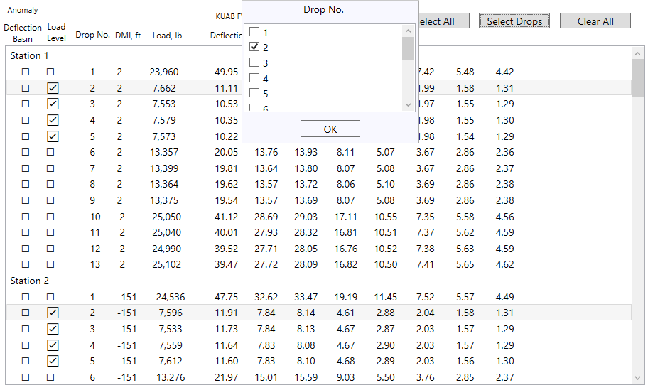
Second FWD drops selected
Figure 3-33. FWD drop selection using the “Select Drops” button and the “Drop No.” menu

Backcalculation Analysis
Before performing a backcalculation analysis, the user must define the pavement layer structure, load an FWD file, select the desired FWD drops, and finally assign an iteration tolerance as shown in Figure 3-34.
To begin the backcalculation, click the “Backcalculate” button in the “Section” module (Figure 3-34). Backcalculation can be performed in a single analysis mode if one FWD drop is selected or in a batch analysis mode if more than one drop is selected. In the single mode, the backcalculation results for the selected drop will appear in the main interface. In batch mode, the backcalculation results will be saved in a .csv output file. When selecting multiple drops, a dialog box will appear asking the user to confirm that a batch analysis is desired (Figure 3-34). The user will then be asked to supply a file name and folder address where the .csv file will be saved. Selecting “Cancel” in the pop-up dialog box will abort the backcalculation process. The analysis outputs are the backcalculated modulus values, the root mean square error (RMSE), iteration number, and the calculated deflections.
The backcalculation “Status” submodule (Figure 3-34) updates the user on the progress of backcalculation actions. The progress bar in blue estimates time remaining to complete the single or batch backcalculation. The text box to the right of the bar shows the drop number.
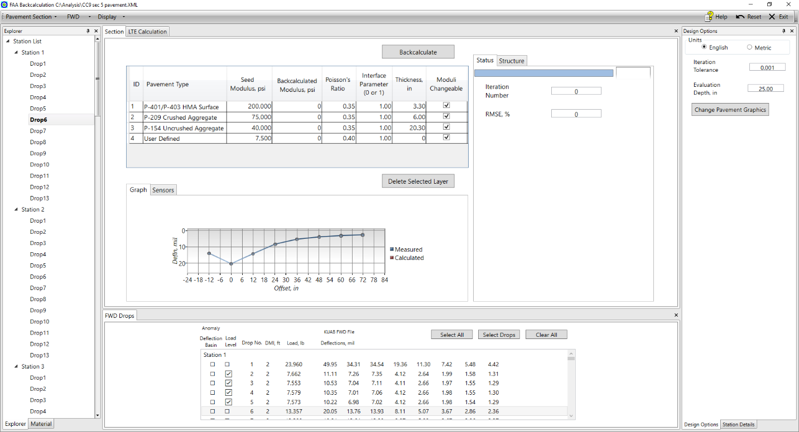
Start/Stop Backcalculation
Backcalculation status
Assign iteration tolerance
Figure 3-34. Start batch backcalculation analysis

Iteration Tolerance
Iteration tolerance is a user assigned dimensionless parameter that controls the stoppage criteria of the iterative process used in backcalculation analysis. At the end of each iteration, BAKFAA calculates an error term internally as defined in Equation 3-1.
$$Err=\sum_{i=1}^{N}{{\left({MD}_{i}-{CD}_{i}\right)}^{2}} (3-1)$$
where MD_{i} and CD_{i} are the measured and calculated deflections at sensor i, respectively, and N is the number of FWD sensors. The iteration tolerance rtol at the end of each iteration is defined in Equation 3-2:
$$rtol=2×\frac{{(Err)}_{j}-{(Err)}_{j+1}}{{(Err)}_{j}+{(Err)}_{j+1}} (3-2)$$
where (Err)_{j} and (Err)_{j+1} are the errors at two consecutive iterations j and j+1, respectively. BAKFAA stops the backcalculation when the rtol is less than the user defined iteration tolerance.
The default value for iteration tolerance is 0.001, however the user can define another value based on the needs of the analysis being performed. The appropriate value for iteration tolerance is typically between 0.001 and 0.1. The user may choose to iterate values through this range to achieve desired accuracy, however higher iteration tolerance values may result in higher RMS error.

Iteration Number
Iteration number is an analysis output value that indicates the number of iterations completed in a backcalculation analysis. The user cannot change the iteration number. When multiple drops are analyzed, the iteration number for each drop is recorded and saved in the .csv output file. The interface displays the iteration number of the last drop selected.

Root Mean Square Error
The root mean square error (RMSE) between the measured and calculated deflections is an analysis output value and is calculated as a percentage per ASTM D5858-96 (2020) “Standard Guide for Calculating In Situ Equivalent Elastic Moduli of Pavement Materials Using Layered Elastic Theory” as defined in Equation 3-3.
$$RMSE={100×\left[\frac{1}{N}\sum_{i=1}^{N}{{\left(\frac{d_{i}^{c}-d_{i}^{m}}{d_{i}^{m}}\right)}^{2}}\right]}^{1/2} (3-3)$$

where:
$d_{i}^{c}$ : Calculated deflection for i^{th} sensor
$d_{i}^{m}$ : Measured deflection for i^{th} sensor
N: Number of sensors

In a single analysis, the RMSE is displayed in the “Section” module under the “Status” tab. In a batch analysis, the RMSE values for each selected drop are recorded in the .csv output file. The interface displays the RMSE of the last drop selected.

Backcalculated Modulus
In a single drop analysis, the backcalculated modulus values for each layer will be displayed in the “Backcalculated Modulus” column of the “Section” module. In a batch analysis, the “Geo. Mean Backcalculated Modulus” column displays the geometric mean of the backcalculated layer modulus values for the selected drops (see Figure 3-35) and the values for each selected drop are recorded in the .csv output file.

Calculated Deflections
BAKFAA reports the calculated deflections at the FWD sensor locations for all drops selected for the backcalculation analysis. In a single drop analysis, the calculated deflections are displayed in the sensor table of the “Section” module. In a batch analysis, the calculated deflections are saved in the .csv file and the sensor table displays the calculated deflections for the last drop selected.

.CSV Output File
In a batch analysis, the results of the backcalculation will be saved in a .csv output file in a user specified directory. The .csv output file in BAKFAA contains the following information for each FWD drop selected:
- Pavement structure (pavement type, seed modulus, Poisson’s ratio, interface parameter, thickness, and moduli changeable selection for each layer)
- FWD information (DMI, drop no., load, and operator comments or remarks)
- Iteration tolerance
- Backcalculated modulus
- RMSE
- Iteration number
- Measured deflections for each selected FWD drop
- Calculated deflections for each selected FWD drop
- LTE values (if selected by the user)

Show Output
Located under the “Display” drop-down in the top toolbar, the “Show Output” option opens a sub-window that displays a summary of the backcalculation results as shown in Figure 3-35. In a single drop analysis, the sub-window displays the backcalculation results for the specified drop, including the backcalculated modulus values, RMSE, iteration number, and calculated deflections. “Show Output” also displays FWD information and calculated Impulse Stiffness Modulus (ISM) as defined in Equation 3-4:
$$ISM=\frac{L}{D_{0}} (3-4)$$
where L is the applied FWD load and D₀ is the deflection under FWD load plate.
In a batch analysis, the FWD information and analysis results (calculated deflections, RMSE, iteration number, and ISM) are only displayed for the last test point selected.
In a batch analysis, the “Show Output” sub-window displays the geometric mean and arithmetic mean of the backcalculated modulus values for the selected points. For example, the arithmetic and geometric means of the backcalculated modulus of layer No. 1 are shown in Equations 3-5 and 3-6:
$$Arithmetic Mean \left(E_{1}\right)=\frac{1}{n}\left(E_{11}+E_{12}+…+E_{1n}\right) (3-5)$$
$$Geometric Mean \left(E_{1}\right)={\left(E_{11}×E_{12}×…×E_{1n}\right)}^{1/n} (3-6)$$
where n is the number of test points selected for backcalculation. E₁₁, E₁₂ and E_{1n} are the backcalculated modulus of layer 1 at test points 1, 2, and n.
The “Show Output” sub-window also contains an “FWD File Image” button displaying the content of the FWD file loaded (if a file is loaded) and a “LEAF Output” button showing the results of a LEAF analysis.
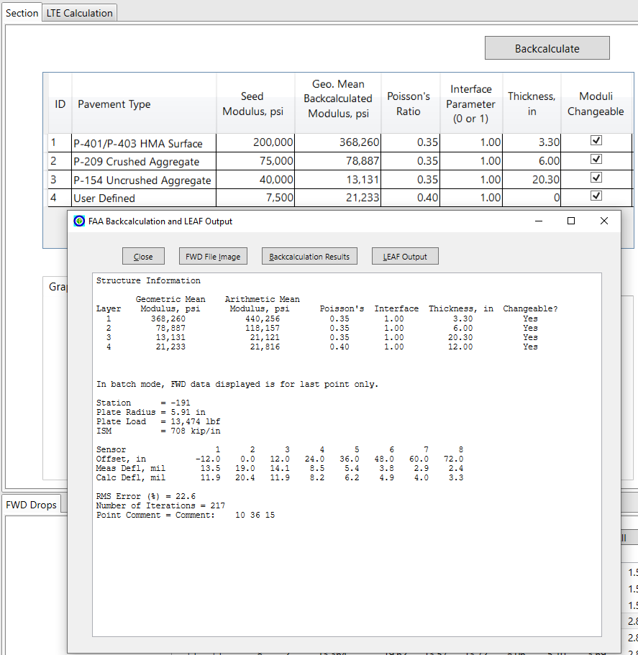
Backcalculation output in batch analysis
Geometric mean of backcalculated moduli
Figure 3-35. “Show Output” sub-window displaying backcalculation results of a batch analysis

Abort an In-Progress Backcalculation
When a backcalculation is being performed, the “Backcalculate” button will change to read “Stop Backcalculate”. The user can abort an in-progress backcalculation by clicking the “Stop Backcalculate” button (see Figure 3-34). Backcalculation results can still be found up to the point of termination in the “Show Output” sub-window for a single analysis and in the .csv output file in a batch analysis.

Batch Graph
The “Batch Graph” function displays graphs showing either measured and calculated deflections or backcalculated layer moduli. The x-axis of the graphs is the DMI information of the selected test points. The sub-window is opened by clicking the “Display” drop-down from the tool bar and then selecting “Batch Graph”.
The “Deflections” tab displays the graph of the measured and calculated deflections for two sensors: 1) the sensor under the FWD load plate (e.g., D₀) and 2) the outermost sensor from the load plate (e.g., D₇₂). Select FWD drops in the “FWD Drops” module to view the measured deflections on the batch graph. Through use of the checkboxes in the tab, the user may choose to display either measured or calculated deflections or both simultaneously. The user may also toggle on and off any individual drop or individual sensor using the “Drop No.” and “Exclude Drop” boxes, respectively. It should be noted that the batch graph will only display information for drops selected in the “FWD Drops” module. For example, if there are four drops, 1 through 4, and only drops 3 and 4 are selected in the main interface, the batch graph will not be able to display drops 1 and 2, even if the user toggles them on using the checkboxes in the “Drop No.” box. The user may display measured deflections for any drop by closing the “Batch Graph” sub-window, altering the drop selections in the “FWD Drops” module, and reopening the “Batch Graph” sub-window. However, calculated deflections will only be displayed for drops included in the backcalculation analysis.
The “Modulus” sub-window displays the backcalculated modulus values for the drops and locations included in the backcalculation analysis in a logarithmic scale (for the vertical axis). The user can toggle off any layer of the pavement using the checkboxes in the “Layer” box.
Figure 3-36 shows an example of the “Deflections” tab in the “Batch Graph” sub-window. The example includes a backcalculation analysis performed for drop no. 6 at twelve stations (drop locations). Each drop and station are selected in the main window. The batch graph shows the measured and calculated deflections for sensors at 0-inch (D₀) and 72-inch offset (D₇₂) for all selected stations. Since the analysis used only drop no. 6, the batch graph shows the deflections only for that drop. Toggling on drop no. 2 will not change the graph in this example. Figure 3-37 shows the “Modulus” tab of the above example. The graph shows the backcalculated modulus values in logarithmic scale with all layers toggled on for display.

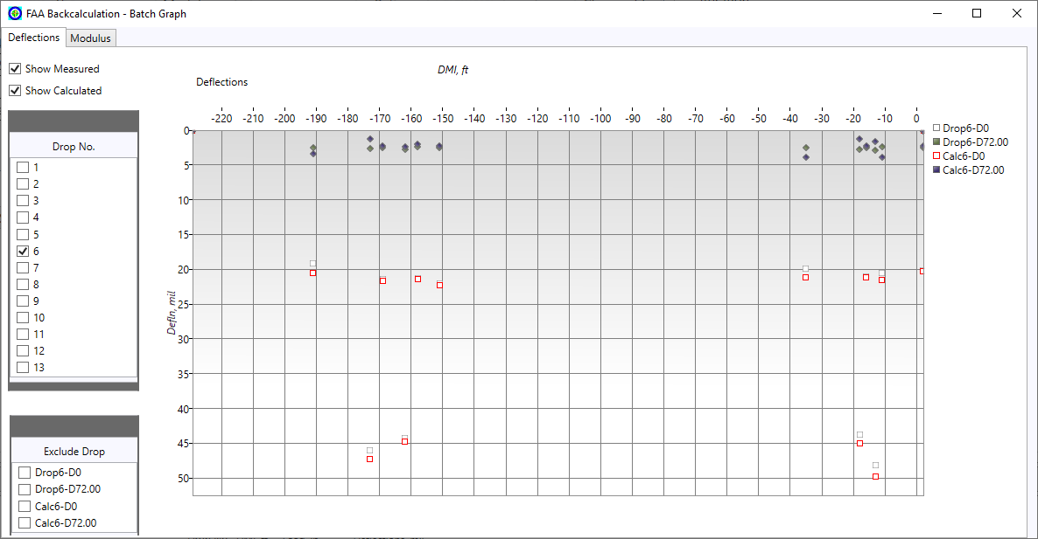
Toggle on to exclude sensor
Toggle on to include other drops
Toggle off to exclude measured or calculated deflections
Figure 3-36. “Batch Graph” sub-window displaying measured and calculated deflections

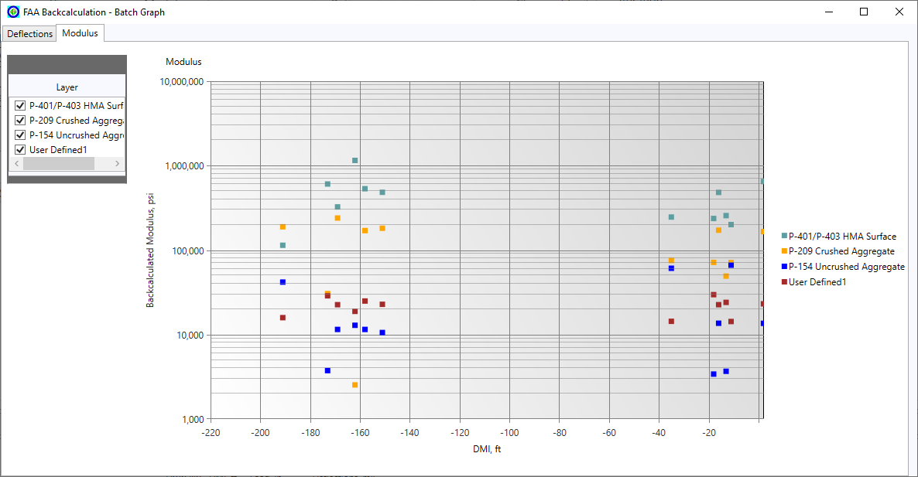
Toggle off to exclude layer
Figure 3-37. “Batch Graph” sub-window displaying backcalculated modulus values

Load Transfer Efficiency (LTE) Calculation
BAKFAA provides the user with the ability to calculate load transfer efficiency (LTE) between two jointed concrete slabs. For this, data from FWD tests performed at slab joints must be used. There are three LTE scenarios based on sensor configuration and layout during testing, each with a unique LTE calculation. These are defined below and shown in the LTE case module (Figure 3-38).
- Case 1 – a sensor at the negative offset (-12 inches), testing is conducted with the joint placed in between the load plate and the sensor at the first positive offset (12 inches).
  - LTE (%): $\frac{d_{2}}{d_{0}}×100$
- Case 2 – a sensor at the negative offset (-12 inches), testing is conducted with the joint placed in between the sensor at the negative offset (-12 inches) and the load plate.
  - LTE (%): $\frac{d_{1}}{d_{0}}×100$
- Case 3 – no sensor at the negative offset (-12 inches), testing is conducted with the joint placed in between the load plate and the sensor at the first positive offset (12 inches).
  - LTE (%): $\frac{d_{1}}{d_{0}}×100$
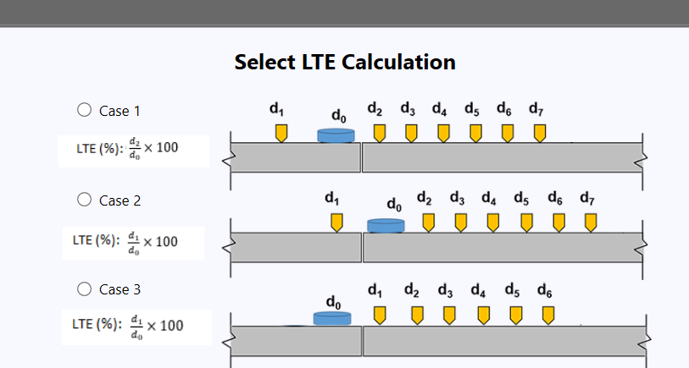
Figure 3-38. LTE cases
To perform the LTE calculation, follow steps listed below and reference Figure 3-39:
- Load the desired FWD file and click on the “LTE Calculation” module.
- Three LTE scenarios will be displayed. Between Cases 1, 2, and 3, select the one that corresponds to the FWD sensor configuration and layout during testing.
- Click on an FWD drop. The calculated LTE will appear in the LTE tab.
BAKFAA will automatically disable Case 1 and 2 for FWD tests with no negative offset sensor or if the user excludes the negative offset sensor. BAKFAA disables Case 3 for FWD tests with a negative offset sensor. In batch analysis, the LTE values are saved in the .csv file.

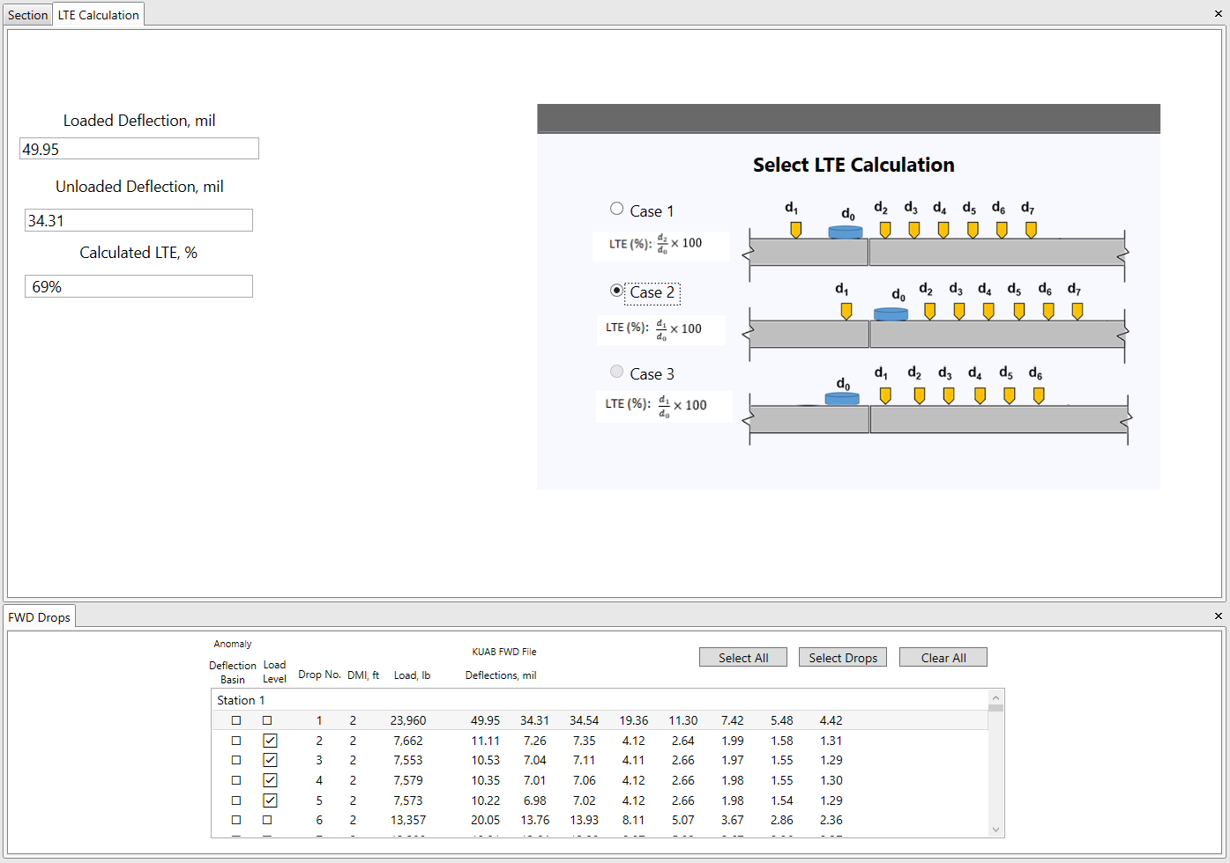
Figure 3-39. LTE calculation in BAKFAA

Select Load and Run LEAF
The FAA Layered Elastic Analysis program (LEAF) is built into BAKFAA, allowing the user to compute pavement responses under various load types. LEAF calculates pavement stress, strain, and deflection values at different evaluation points within the pavement structure using a layered elastic model. Layered elastic models assume that each layer in a pavement structure is homogeneous, isotropic, and linearly elastic. The model is based on the Boussinesq mathematical model which assumes the following:
- The pavement layers extend infinitely in the horizontal direction.
- The bottom layer extends infinitely downward.
- The materials are not stressed beyond their elastic ranges.
LEAF requires modulus of elasticity, Poisson’s ratio, layer thickness, and layer interface condition values to perform the layered elastic analysis. LEAF retrieves the required inputs from the pavement structure defined by the user in the “Section” module. LEAF uses either the seed modulus values or the backcalculated modulus if a backcalculation analysis has been performed. The user can assign the depth of evaluation (the depth at which the pavement responses are calculated) in the “Design Options” module as shown in Figure 4-1.
Figure 4-1 illustrates the inputs required for a LEAF analysis. In this example, since no backcalculation analysis has been performed, LEAF will use the seed modulus values for analysis. Note that continuity in some of the pavement responses between two pavement layers depends on their interface condition. For fully bonded interfaces (interface parameter of 1), continuity exists for the horizontal strains, vertical stress, and deflection. For fully unbonded interfaces (interface parameter of 0), continuity in responses only exist in vertical stress and deflection. The evaluation depth must be assigned so that it represents the target layer. For example, the assigned evaluation depth is 9.29 inches in Figure 4-1 to calculate the pavement responses at the bottom of the P-209 layer, which is located at a depth of 9.30 inches.
To initiate the LEAF analysis, click the “Display” drop-down in the top toolbar and then click “Select Load and Run LEAF” after setting the required values.
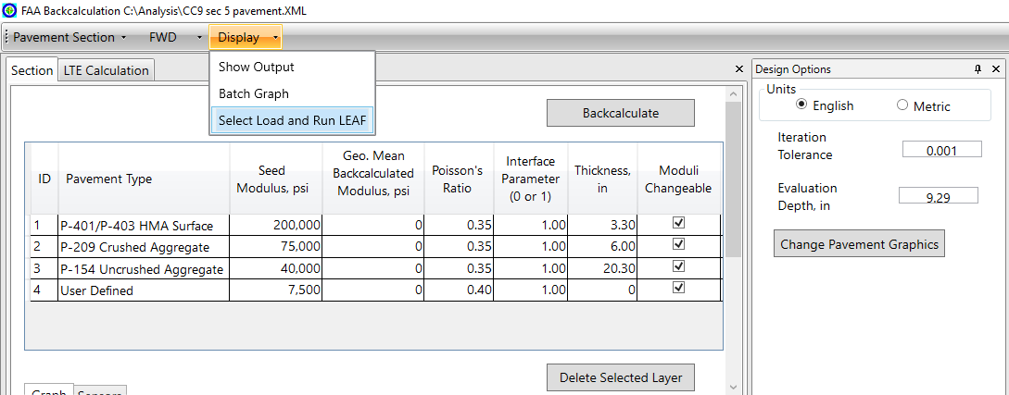
Pavement structure defined by the user for LEAF analysis
LEAF analysis calculates pavement responses at evaluation depth
Figure 4-1. Pavement structure and evaluation depth settings for LEAF analysis
Table 4-1 shows the critical locations, including the desired response to be used and reason why, commonly used in the analysis of pavement structure response.
Table 4-1. Critical locations in analysis of pavement structure responses
Location | Response | Reason for Use
Pavement surface | Deflection | Imposing load restrictions and overlay design
Bottom of HMA layer | Horizontal tensile strain | Predict fatigue failure in the HMA
Top of intermediate layer (Base or Subbase) | Vertical compressive strain | Predict rutting failure in the base or subbase
Top of subgrade | Vertical compressive strain | Predict rutting failure in the subgrade

Load and Gear Configuration
After clicking “Select Load and Run Leaf”, the “FWD Drops” module will be replaced with a “Select Load” module containing the LEAF load library (see Figure 4-2). The load library contains generic gear geometry, aircraft gear configurations, and FWD loading configurations. The user must select the desired load type to perform the LEAF analysis.
The information in the LEAF load library is contained in the file LEAFAircraft.Ext, located in the same directory as the application executable BAKFAA.exe (C:\Program Files\FAA\BAKFAA by default). The user can modify the LEAFAircraft.Ext file, including adding or removing user-defined landing gear geometry or modifying the X and Y coordinates of defined evaluation points. Figure 4-3 provides an example of items in LEAFAircraft.Ext file that define a B-747-400 landing gear within the program. Figure 4-4 shows a schematic of the B-747-400 landing gear parameter.

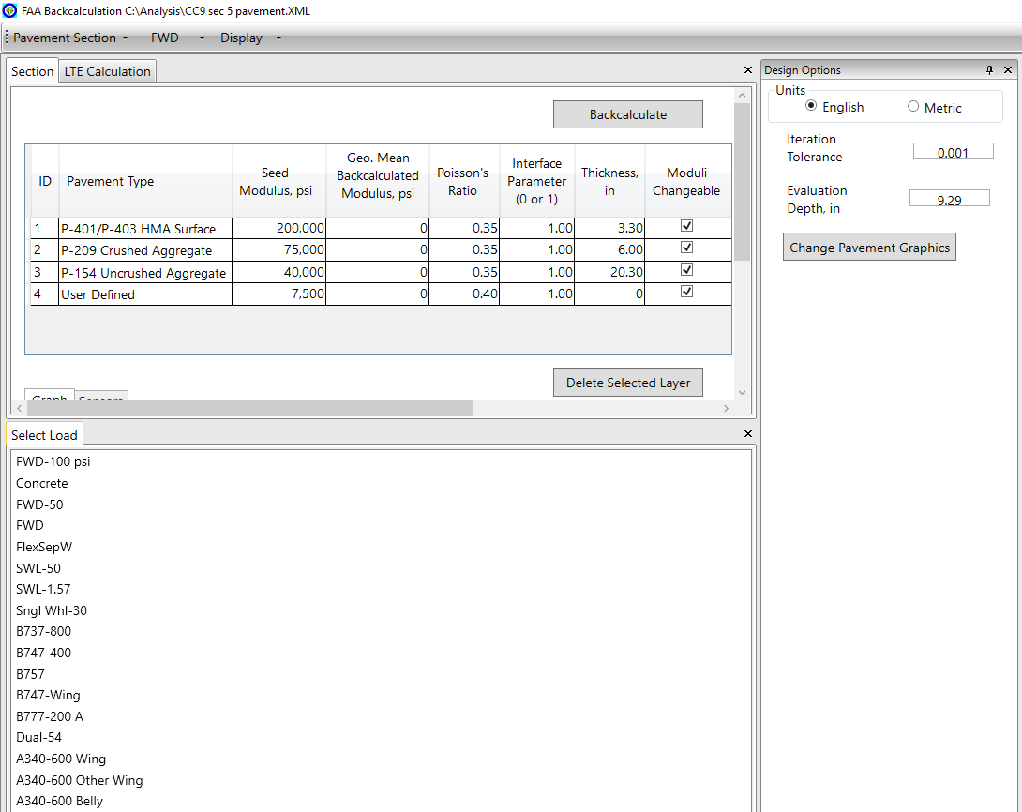
Figure 4-2. Load Library for LEAF analysis
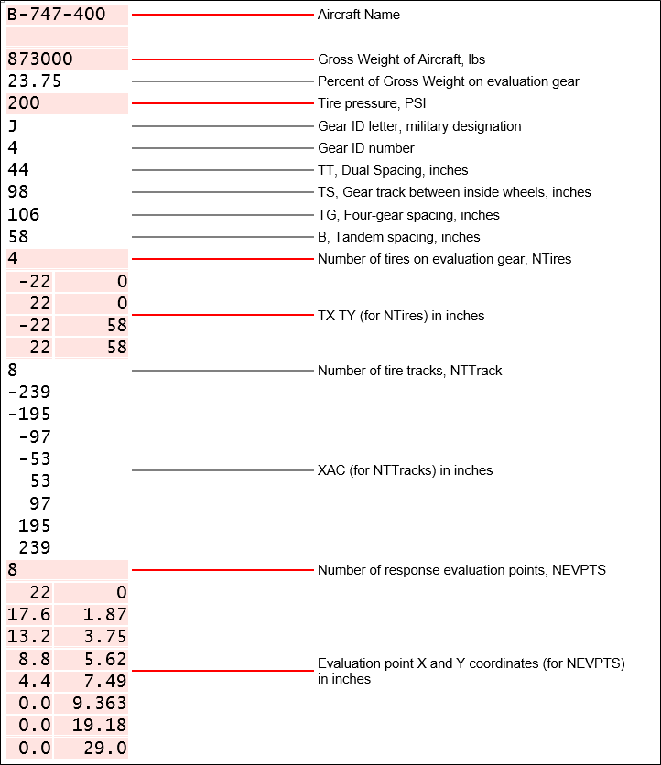
Figure 4-3. Summary of items in the LEAFAircraft.Ext file for a B-747-400 example

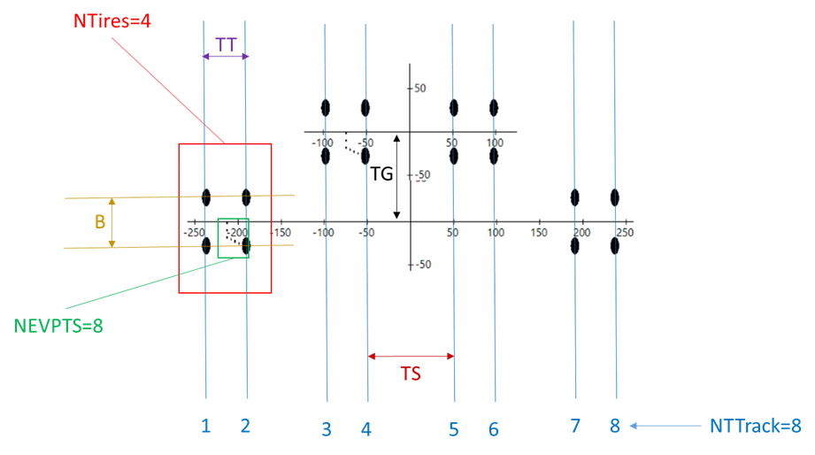
Figure 4-4. Schematic of B-747-400 Landing Gear Parameters in the LEAFAircraft.Ext file

LEAF Output
After defining the pavement layer structure, assigning the target evaluation depth, and selecting the load type from the library, the LEAF output will automatically open the “Show Output” sub-window to view the LEAF output. It can be manually opened by the user by clicking “Display”, “Show Output”, then “LEAF Output”. The LEAF output is an ASCII text document containing:
- Pavement layer structure table
A.1 | Layer no.
A.2 | Thickness
A.3 | Modulus of elasticity
A.4 | Poisson’s ratio
A.5 | Interface condition
- Aircraft table
B.1 | Aircraft gear data table from LEAFAircraft.Ext
B.2 | Aircraft Make/Mode
B.3 | Fraction of load on main gear, percent
B.4 | Gear load
B.5 | Number of tires
- Tire data table from LEAFAircraft.Ext, with loads evenly divided among all tires
C.1 | Tire no.
C.2 | Tire radius
C.3 | Tire contact area
C.4 | Tire contact pressure
C.5 | Tire load
C.6 | X-coordinate
C.7 | Y-coordinate
- Pavement responses at evaluation points, including eval. point no., layer no. (determined by evaluation depth), X-coord, Y-coord, and Z-depth
D.1 | Stress
 | D.1.1 | Vertical
 | D.1.2 | Horizontal Y
 | D.1.3 | Horizontal X
 | D.1.4 | XZ shear
 | D.1.5 | YZ shear
 | D.1.6 | XY shear
D.2 | Strain
 | D.2.1 | Vertical
 | D.2.2 | Horizontal Y
 | D.2.3 | Horizontal X
 | D.2.4 | XZ shear
 | D.2.5 | YZ shear
 | D.2.6 | XY shear
D.3 | Displacement
 | D.3.1 | Vertical
 | D.3.2 | Horizontal X
 | D.3.3 | Horizontal Y

Sample BAKFAA Analysis
This section contains sample analyses using BAKFAA, including backcalculations for three different pavement structures (flexible, rigid, and composite) and an LTE calculation. The data files used for the follow examples, including the FWD files and the saved pavement section .XML files, can be found in the BAKFAA 3.4 setup package, downloadable from the following link:
https://www.airporttech.tc.faa.gov/Products/Airport-Pavement-Software-Programs
To follow along with the examples or for further practice, these files should be downloaded to the computer running BAKFAA.
Also included in this section is a discussion of commonly encountered error messages.

Flexible Pavement Example
This example uses data from an HWD test conducted on a 3-layered flexible pavement. Table 5-1 shows the pavement structure. The HWD test drops include one seating drop of 36 kips (165 kN) and three drops of 12 kips, 24 kips, and 36 kips (55 kN, 110 kN, and 165 kN).
Table 5-1. Composition of pavement layers for the flexible pavement example
Material Type | Thickness (in)
P-401/P-403 Hot Mix Asphalt | 6
P-209 crushed stone base | 12
Subgrade with a CBR of 10

To perform the backcalculation:
- Assign the pavement layer structure provided in Table 5-1 manually or by loading the “Flexible Pavement Structure.xml” file by clicking “Pavement Section” in the toolbar then “Load Pavement Section” and selecting the desired file.
- Assign seed modulus values for each layer. Factors influencing the selection of an appropriate seed modulus value are discussed below.
The knowledge from the asphalt layer temperature can help in the estimation of the seed modulus for that layer. Other factors such as aging conditions and level of damage should also be considered. The FWD file shows the air and pavement surface temperatures as 40°F and 54°F, respectively. The asphalt concrete mid-depth temperature can be estimated using the BELLS equation in accordance with ASTM D7228-06a(2020), “Standard Test Method for Prediction of Asphalt-Bound Pavement Layer Temperatures”. BELLS incorporates the pavement surface temperature recorded by the FWD machine, the time of the day the test was conducted and the average temperature over the past 24-hour period to estimate the asphalt mid-depth temperature. For this example, the mean previous day temperature is equal to 68°F. Using the BELLS equation, the asphalt mid-depth temperature is 60.3°F.
The following exponential equation can be used to estimate the asphalt concrete seed modulus at the testing temperature using a reference modulus corresponding to a reference temperature.
$$E_{T}=E_{Ref}×e^{C\left(T-T_{Ref}\right)} (5-1)$$
where $E_{T}$ = modulus at testing temperature
$T$ = testing temperature at asphalt mid-depth
$E_{Ref}$ = known reference modulus at reference temperature
$T_{Ref}$ = reference temperature
$C$ = coefficient
$C$ is typically taken as -0.036 in US units or -0.065 in SI units. Assuming the reference modulus is 500,000 psi at 77°F, the estimated modulus at 60.3°F would be 912,153 psi. Using a seed modulus of 910,000 psi should be sufficient. Alternatively, any temperature correction relationship for similar asphalt concrete material can be used for this estimation.
Use the default seed modulus of 75,000 psi for the P-209 base layer.
Using the $E=1,500×CBR$ (Heukelom & Klomp 1962) correlation, the subgrade seed modulus would be equal to 15,000 psi.
- Load the saved “Flexible Pavement Example.fwd” file by clicking “FWD” in the ribbon then “Load FWD File” and selecting the file.
- Select drop no. 4 and exclude the sensor at the -12 in. offset.
- Start backcalculation by clicking the “Backcalculate” button.
- Review the backcalculation results.
When reviewing the backcalculation results, use engineering judgment to determine whether the backcalculated modulus values are realistic and if the RMSE is acceptable.
Figure 5-1 shows the resulting backcalculation modulus values. While the RMSE is nearly acceptable, the backcalculated modulus values are not reasonable. The modulus of the asphalt layer is high and the modulus of the base layer is lower than that of the subgrade.
In this example, the following can be performed in an attempt to improve the backcalculation results:
- Change the seed modulus.
- Change the iteration tolerance.
- Add a stiff layer below the subgrade.
If the seed modulus values for the base and subgrade are changed to 60,000 psi and 10,000 psi, respectively, the backcalculated modulus values are more realistic, but the RMSE of 14.6% is relatively high (Figure 5-2). Further attempts should be made to improve the analysis.
In the next attempt, add a stiff layer with a seed modulus of 100,000 psi 10 ft. below the pavement surface. The backcalculation should be repeated by treating the stiff layer modulus as both changeable and not changeable (fixed) and the results compared. Figure 5-3 shows the backcalculation results where the stiff layer was fixed in the backcalculation analysis. In this case, the resulting backcalculated modulus values are realistic and the RMSE is less than 5%. The asphalt modulus of 1,113,820 psi at the test temperature 60.3°F is equivalent to a modulus of 611,000 psi at the reference temperature of 77°F. It is important to adjust all temperature-dependent materials to a reference temperature for reporting purposes. The backcalculated base modulus of 69,687 psi is reasonably consistent with the default modulus for the P-209 aggregate base material. Finally, the backcalculated subgrade modulus of 10,289 psi (equivalent to CBR of 6.7) is lower than the assumed subgrade CBR, but it is still acceptable.
Converted into ksi, the results of this analysis for all drops are presented in Table 5-2.

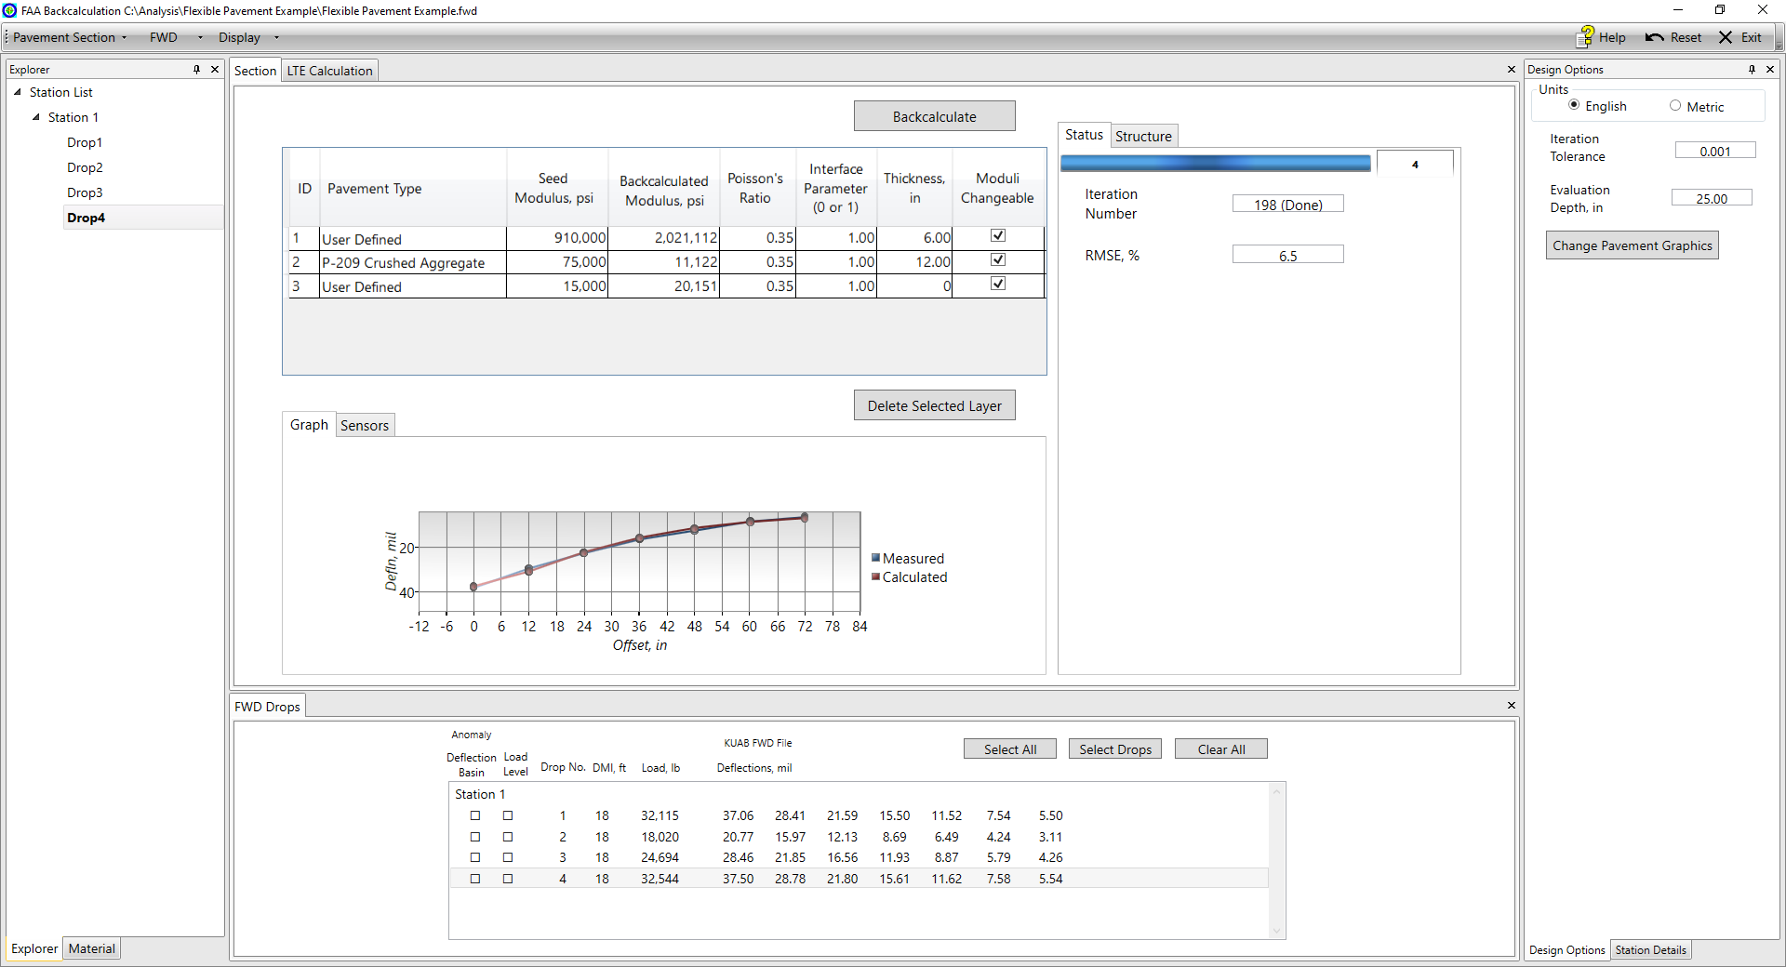
Figure 5-1. Backcalculation results for flexible pavement example (first attempt)
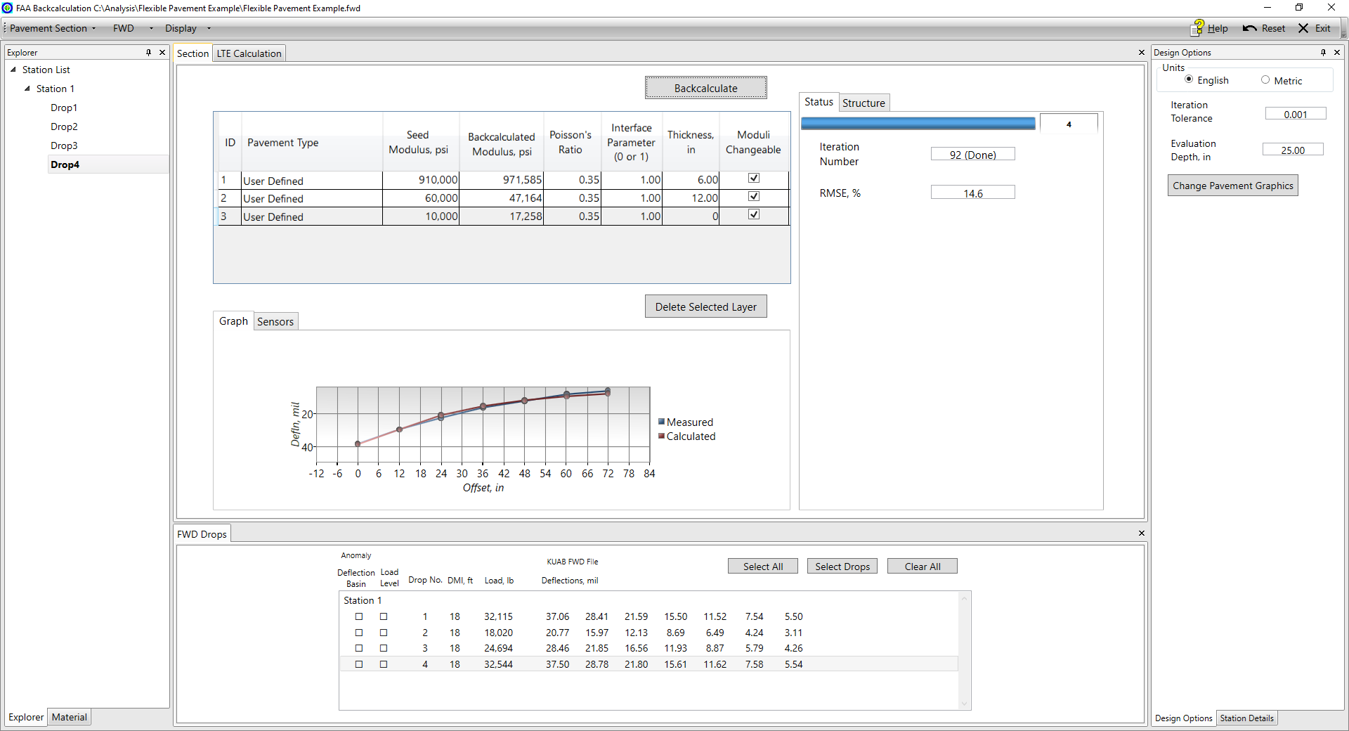
Figure 5-2. Backcalculation results for flexible pavement example (second attempt)
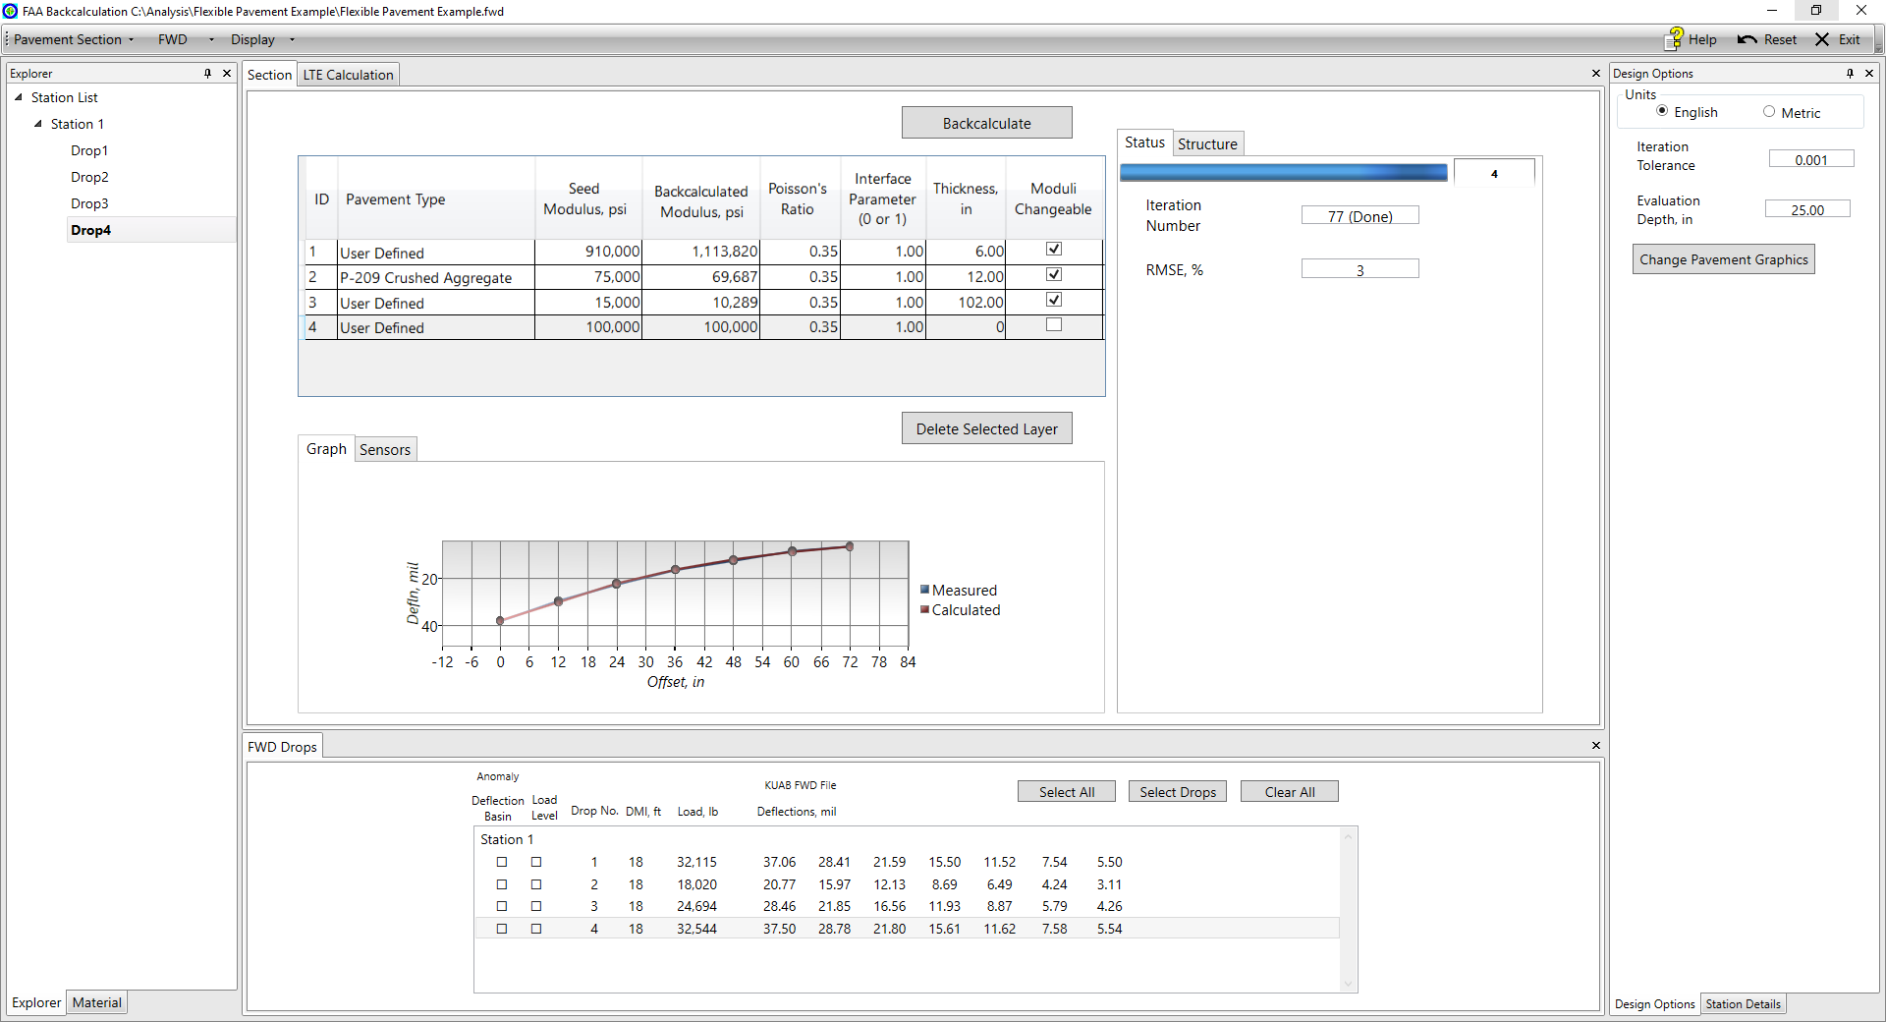
Figure 5-3. Backcalculation results for flexible pavement example (third attempt)
Table 5-2. Flexible pavement example backcalculated layer modulus values and statistics
Drop¹ | Asphalt Concrete (ksi)² | Aggregate Base (ksi) | Subgrade (ksi) | RMSE %
2 | 1,1150 [630] | 68.3 | 10.2 | 2.8
3 | 1,122 [615] | 69.8 | 10.2 | 2.9
4 | 1,115 [611] | 69.8 | 10.3 | 3
Geometric Mean² | 1,129 [619] | 69.3 | 10.2 | 2.9
Standard Deviation² | 1.01 | 1.011 | 1.0 | 0.1
1. Seating drop is not typically included in analysis.
2. At tested temperature and at reference temperature of 77°F between brackets.

Rigid Pavement Example
This example uses data from an HWD test conducted on a 3-layered rigid pavement and performs both a single analysis and a batch analysis. Table 5-3 shows the pavement structure. The HWD test drops are 30 kips, 32 kips, and 36 kips (133 kN, 142 kN, and 160 kN) with testing only performed at the center of the slabs.
Table 5-3. Composition of pavement layers for the rigid pavement example
Material Type | Thickness (in)
P-501 Cement concrete pavement | 14
P-156 Cement Treated Subgrade | 12
Subgrade with a CBR of 6
To perform the single analysis backcalculation:
- Assign the pavement layer structure provided in Table 5-3 manually or by loading the saved “Rigid Pavement Structure.xml” file by clicking “Pavement Section” in the toolbar then “Load Pavement Section” and selecting the desired file.
- Assign seed modulus values for each layer as shown in Figure 5-4.
- Load the saved “Rigid Pavement Example.FWD” file by clicking “FWD” in the toolbar then “Load FWD File” and selecting the file.
- Select drop no. 3 at DMI location of 200 ft.
- Start backcalculation by clicking the “Backcalculate” button.
- Review the backcalculation results.
While the RMSE is low (1.0%), the backcalculated modulus values are not reasonable, as shown in Figure 5-4. After adding a stiff layer 10 ft. below the pavement surface, rerun the backcalculation. In this case, the backcalculated modulus values are reasonable and the RMSE is low (1.6%), as shown in Figure 5-5.
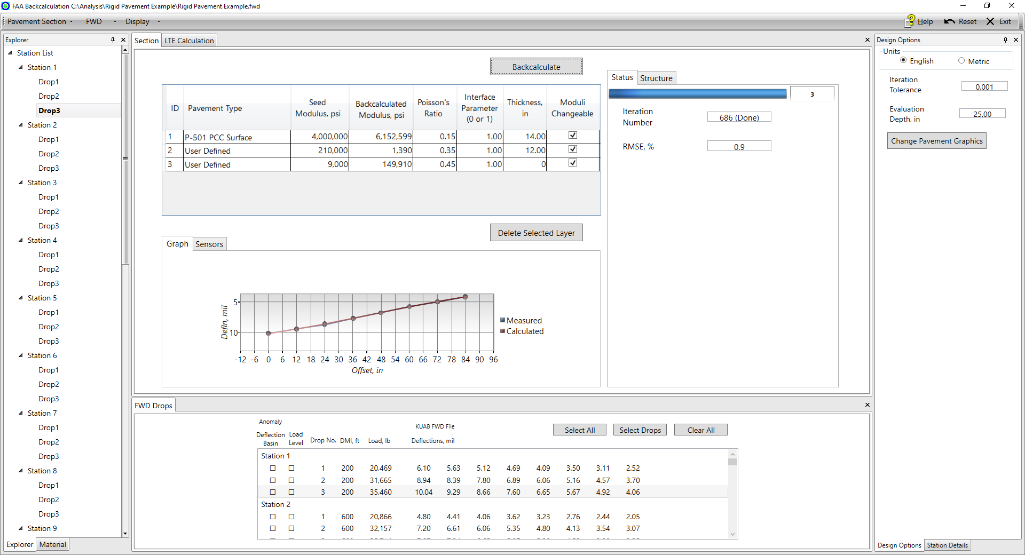
Figure 5-4. Backcalculation results for rigid pavement example (first attempt)
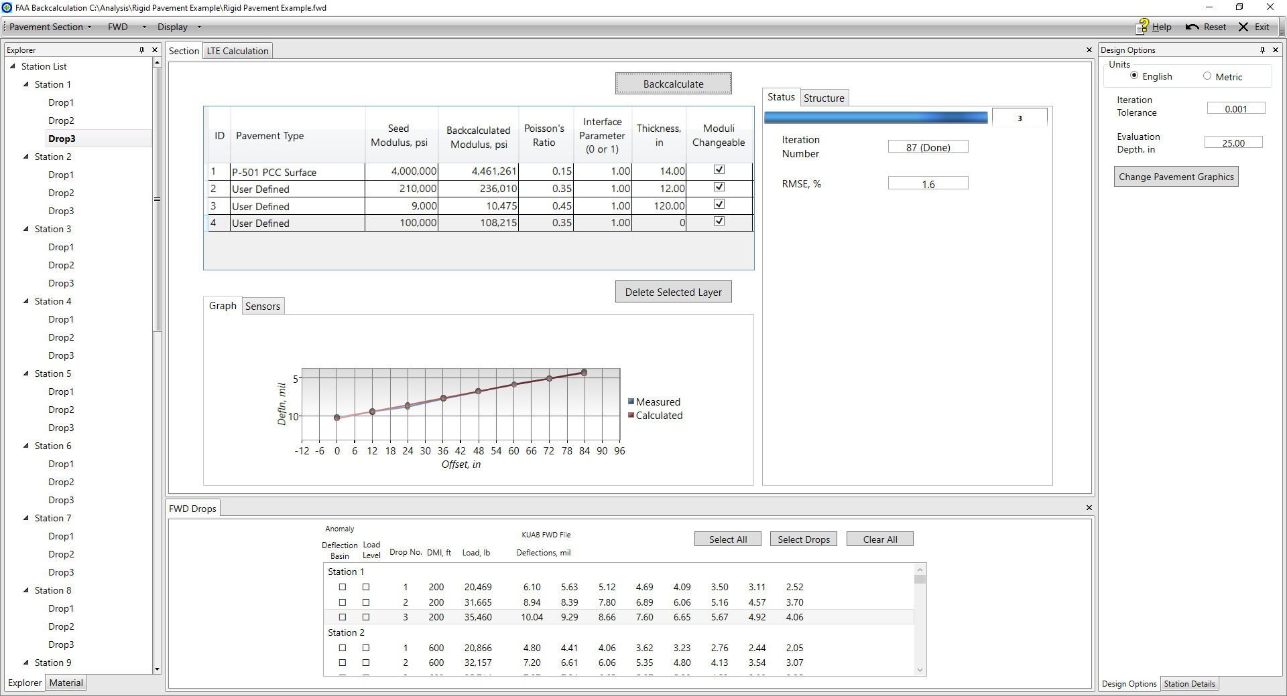
Figure 5-5. Backcalculation results for rigid pavement example (second attempt)
To perform the batch analysis backcalculation:
- Assign the pavement layer structure using the refined structure from the single analysis backcalculation above, as shown in Figure 5-5. This can be done manually or by loading the saved “Rigid Pavement Structure_Stiff Layer.xml” file.
- Assign seed modulus values for each layer as shown in Figure 5-5.
- Load the saved “Rigid Pavement Example.FWD” file.
- Select the third load level drops (drop no. 3) for all test locations by clicking the “Select Drop” button in the “FWD Drops” module. Select drop number “3” from the menu, then click “OK”.
- Start backcalculation by clicking the “Backcalculate” button.
- When prompted, click “Yes” to performing a batch analysis and assign a file path to save the .csv file.
- Click the “Display” drop-down then “Batch Graph” to display the backcalculated deflections and modulus values and review the results, as shown in Figure 5-6.
The test location at 6,600 ft. seems to be an outlier based on the very high backcalculated PCC modulus of 12,000 to 13,000 ksi. Inspection of the deflection basin at DMI of 6,600 (Figure 5-7) reveals an unusual deflection with minimal decrease in sensor deflections at offset distances greater than 48 in. This point can be removed from the backcalculation by three methods:
- Delete the drops for that location from the FWD data “View FWD File” sub-window (Figure 5-8).
  - Click “FWD” in the toolbar then “View FWD File” to open the sub-window.
  - Under the “Delete Drop” column, check the boxes for the drops at the 6,600 ft. location.
  - Click the “Update Data” button. This will remove the FWD data for this location from the loaded FWD data used in the backcalculation. (Note: This will not affect the original FWD file saved to the computer.)
  - Rerun the backcalculation.
- Deselect the drop for that location.
  - In the “FWD Drops” module, deselect the highlighted drop. This will remove it from the backcalculation analysis, but will not remove it from the loaded FWD data.
  - Rerun the backcalculation.
- Delete the results for that drop and location manually in the output .csv file.
Converted to ksi, the backcalculated modulus values and associated statistics after removing the outlier test point are presented in Table 5-4.
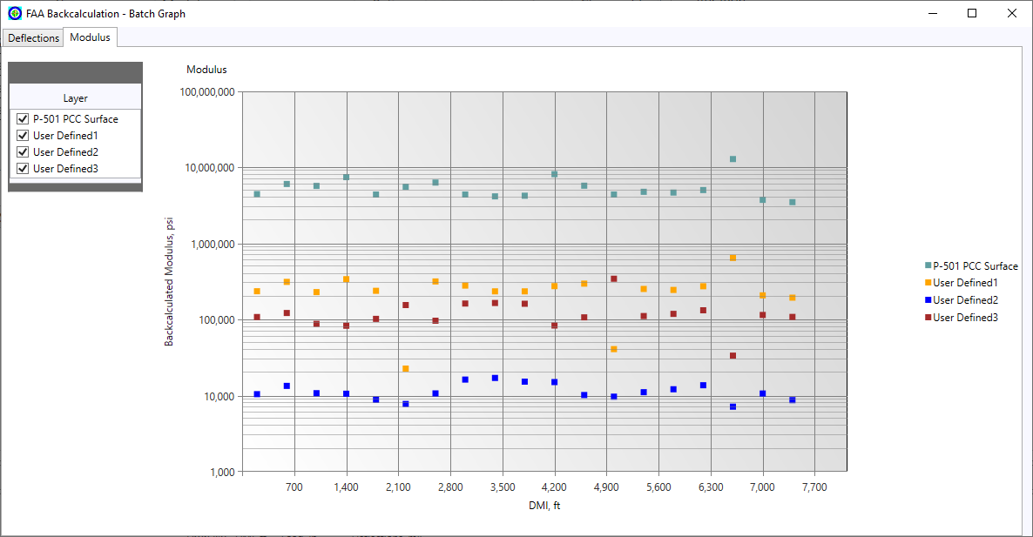
Figure 5-6. Backcalculated layer modulus values for all test points for drop no. 3 in rigid pavement example
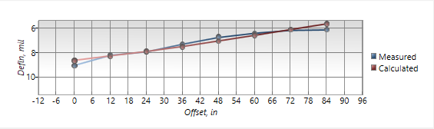
Figure 5-7. Deflection basin at DMI of 6,600 ft. showing unusual deflections in the rigid pavement example
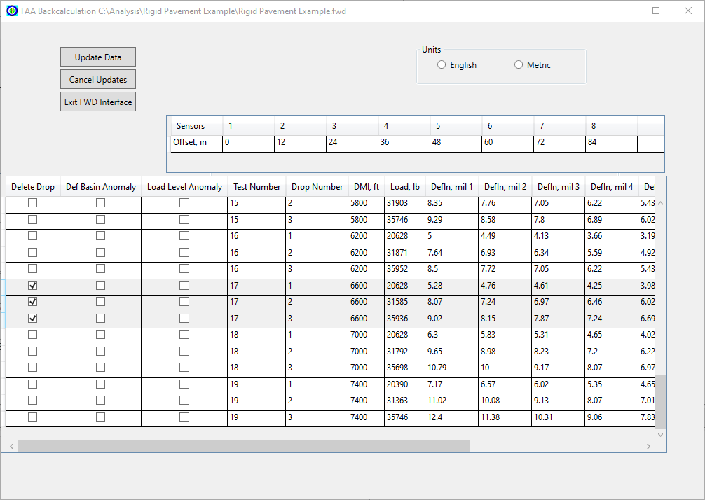
Figure 5-8. FWD data for DMI of 6,600 ft. removed using the “View FWD File” sub-window in the rigid pavement example
Table 5-4. Rigid pavement example layer modulus values and statistics
Parameter¹ | PCC (ksi) | Cement Treated Subgrade (ksi) | Subgrade (ksi)
Layer Modulus Geometric Mean | 5,032 | 203 | 11.5
Geometric Standard Deviation Factor (STDF) | 1.255 | 2.04 | 1.252
16th Percentile (Average/STDF) | 4,009 | 99 | 9.2
1. Excluding outlier at DMI 6,600 ft.

Composite Pavement Example
This example uses data from an HWD test conducted on a 3-layered composite pavement. Table 5-5 shows the pavement structure. The HWD test drops include one unrecorded seating drop of 32 kips and three drops of 32 kips, 42 kips, and 54 kips (142 kN, 186 kN, and 240 kN). The FWD file shows the air and pavement surface temperatures ranging from 52°F to 57°F and 46°F to 50°F, respectively. This example will use three approaches: default seed modulus values, temperature-adjusted P-401 seed modulus value, and fixed P-401 modulus value.
Table 5-5. Composition of pavement layers for the composite pavement example
Material Type | Thickness (in)
P-401/P-403 Hot Mix Asphalt | 2.25
P-501 Portland Cement Concrete | 10
Subgrade with a CBR of 15
To perform the batch analysis backcalculation:
- Assign the pavement layer structure provided in Table 5-5 manually or by loading the saved “Composite Pavement Structure.xml” file by clicking “Pavement Section” in the toolbar then “Load Pavement Section” and selecting the desired file.
- Assign seed modulus values for each layer as shown in Figure 5-9 (BAKFAA default values).
- Load the saved “Composite Pavement Example.FWD” file by clicking “FWD” in the toolbar then “Load FWD File” and selecting the file.
- Select drop no. 2 for all test points.
- Start backcalculation by clicking the “Backcalculate” button.
- When prompted, click “Yes” to performing a batch analysis and assign a file path to save the .csv file.
- Review the results.
The first approach using default seed modulus values results in highly variable P-401 and P-501 layer backcalculated modulus values, as shown in Figure 5-10. Additionally, the geometric mean of the P-401 layer backcalculated modulus values (approximately 517 ksi) is very low when considering the low air and surface temperatures recorded during the HWD testing. These factors indicate that the backcalculation analysis should likely be modified to achieve better results.
The second approach is to adjust the asphalt layer seed modulus value for temperature. The previous day average air temperature is equal to 21°F. Using the BELLS equation, the asphalt mid-depth temperature in the range of 42°F to 46°F is calculated, with an average of 44°F. Assuming the reference modulus is 500 ksi at 77°F, the seed modulus at 42°F would be equal to 1,700 ksi using Equation 5-1. Using this value for the seed modulus of the P-401 layer and repeating the backcalculation analysis results in the backcalculated modulus values shown in Figure 5-11 and Figure 5-12. The layer modulus values for the majority of the test points are reasonable with relatively less variability compared to the results from the analysis using the default seed modulus values.
The third approach is to fix the modulus value of the asphalt. This can be done for composite pavement analysis due to the low stiffness of the surface layer relative to the P-501 layer. As seen in Figure 5-13, unchecking the “Moduli Changeable” box for the asphalt layer fixes the modulus value in the backcalculation. Fixing the asphalt modulus to 1,700 ksi results in layer modulus values similar to those in the second approach, as shown in Figure 5-14.
The backcalculated modulus values and statistics for the three approaches are shown in Table 5-6 using a log-normal distribution. The high variability in the backcalculated P-401 modulus values for the first approach is reflected by the high standard deviation factor of 2.326. The backcalculated layer modulus values for the second and third approaches are relatively similar, with those from the second approach (temperature-adjusted seed modulus values) being the most reasonable.
Of special note is the fact that the backcalculated subgrade modulus is higher than the target subgrade modulus (using a CBR of 15). This is a common problem when performing static backcalculation for stiff pavement structures such as rigid or composite pavements.

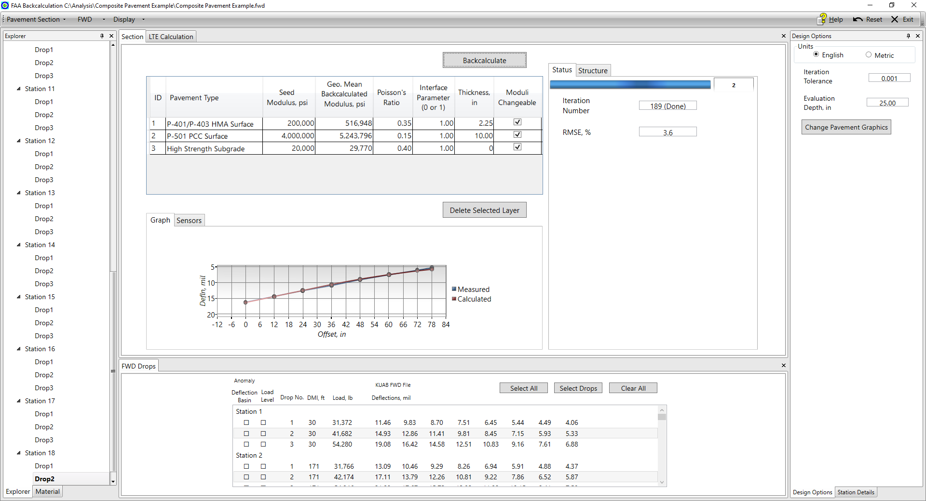
Figure 5-9. Backcalculation analysis using default seed modulus values in the composite pavement example
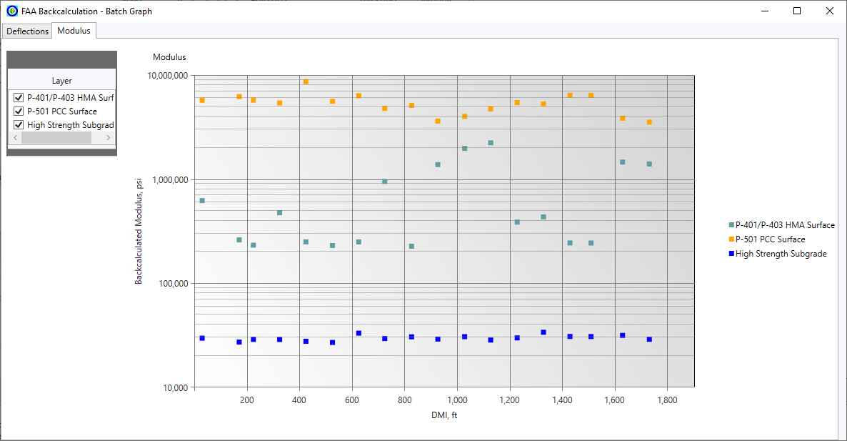
Figure 5-10. Backcalculated layer modulus values for drop no. 2 at all test points using default seed modulus in the composite pavement example
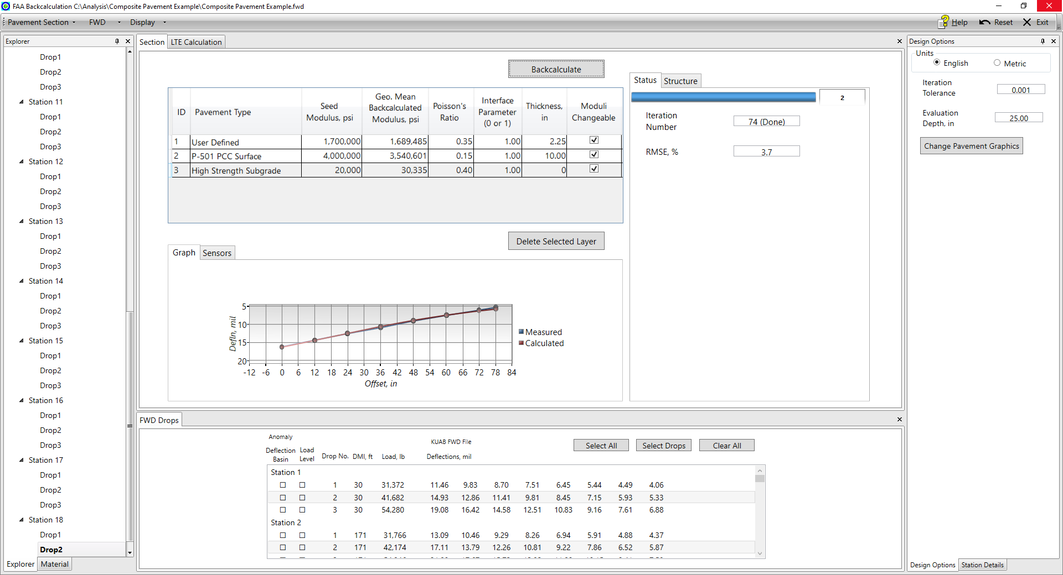
Figure 5-11. Backcalculation analysis using temperature-adjusted P-401 modulus in the composite pavement example
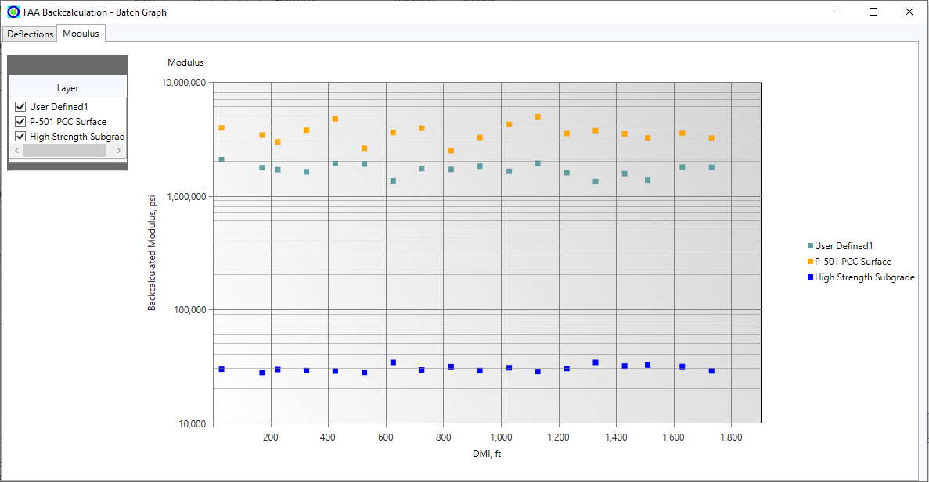
Figure 5-12. Backcalculated layer modulus values for drop no. 2 at all test points using temperature-adjusted P-401 seed modulus in the composite pavement example
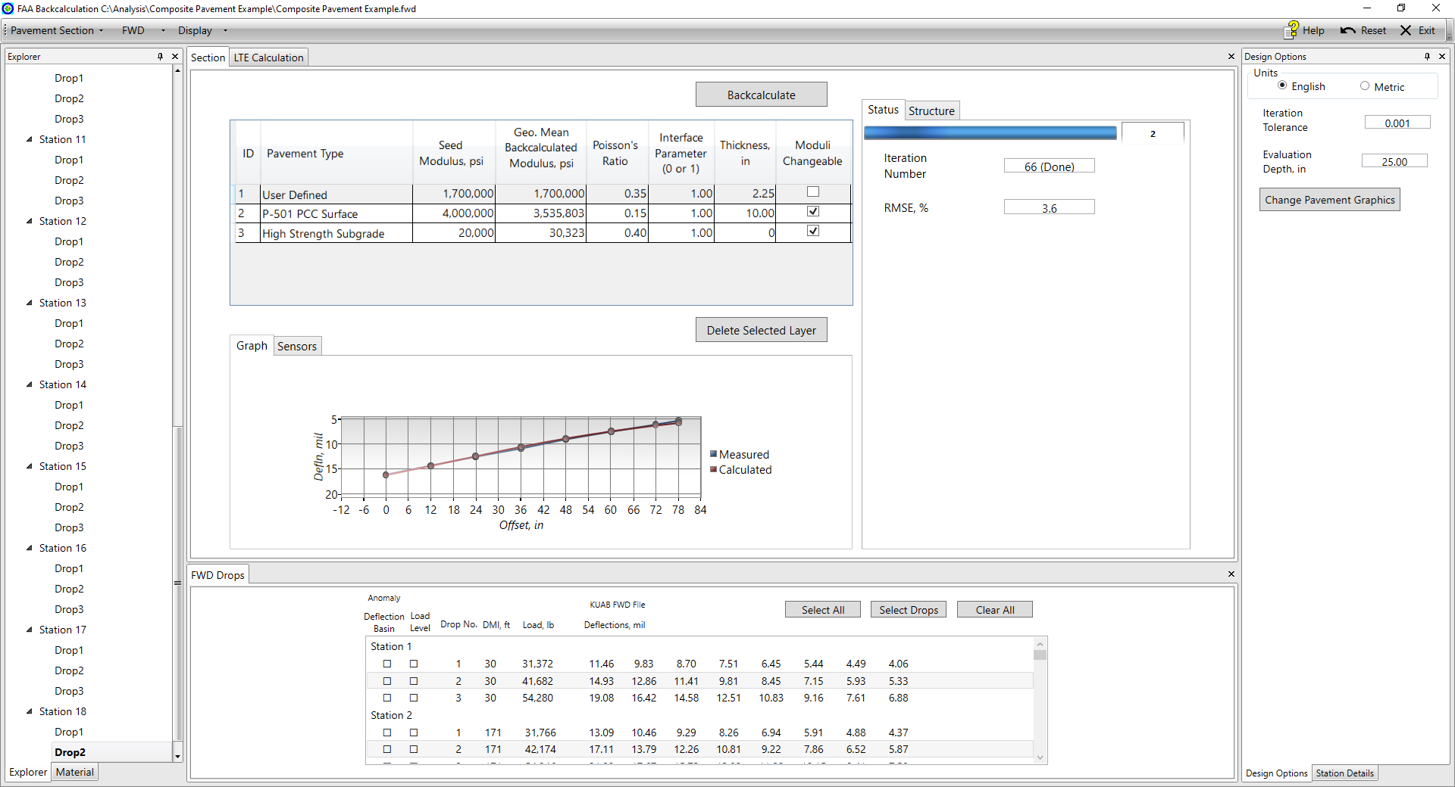
Figure 5-13. Backcalculation analysis using fixed P-401 modulus value in the composite pavement example
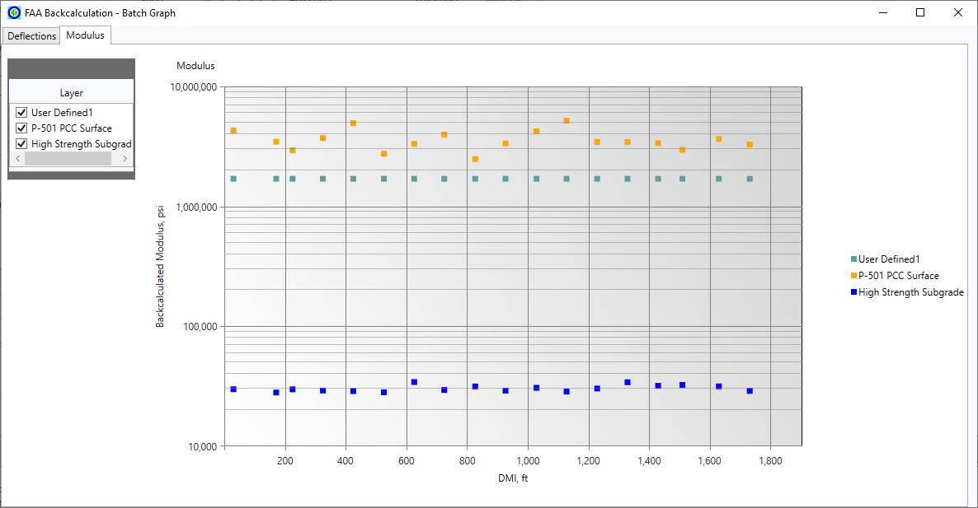
Figure 5-14. Backcalculated layer modulus values for drop no. 2 at all test points using fixed P-401 modulus value in the composite pavement example
Table 5-6. Composite pavement example backcalculated layer modulus values and statistics for three approaches
Case | Parameter¹ | Layer Modulus (ksi)
Case | Parameter¹ | P-401 | P-501 | Subgrade
Default Seed Moduli | Average | 517 | 5,244 | 29.8
Default Seed Moduli | Standard Deviation Factor (STDF) | 2.326 | 1.258 | 1.063
Default Seed Moduli | 16th Percentile (Average/STDF) | 222 | 4,169 | 28.0
Adjusted P-401 Modulus | Average | 1,689 | 3,541 | 30.3
Adjusted P-401 Modulus | Standard Deviation Factor (STDF) | 1.133 | 1.194 | 1.065
Adjusted P-401 Modulus | 16th Percentile (Average/STDF) | 1,491 | 2,966 | 28.5
Fixed P-401 Modulus | Average | 1,700 | 3,536 | 30.3
Fixed P-401 Modulus | Standard Deviation Factor (STDF) | 1.000 | 1.209 | 1.064
Fixed P-401 Modulus | 16th Percentile (Average/STDF) | 1,700 | 2,923 | 28.5
1. Based on log-normal distribution.

LTE Calculation Example
This example uses data from an HWD test conducted on transverse joints of a jointed rigid pavement system. The HWD test configuration at the joints involves one sensor at the -12 in. offset placed on one slab and the load plate and other sensors placed on the adjacent slab. This corresponds to Case 2 as shown in Figure 5-15.
To perform the LTE calculation:
- Load the saved “RW 16L34R Transverse Joint Tests.F25” file by clicking “FWD” in the toolbar then “Load FWD File” and selecting the file.
- Select a drop and location to perform the LTE calculation (in this example, drop no. 3 at DMI location of 400 ft.).
- Click the “LTE Calculation” module.
- Select the appropriate case (in this example, Case 2).
- Review the results in the LTE module, including loaded deflection, unloaded deflection, and the LTE percentage.
For this example, the LTE value is 86%.
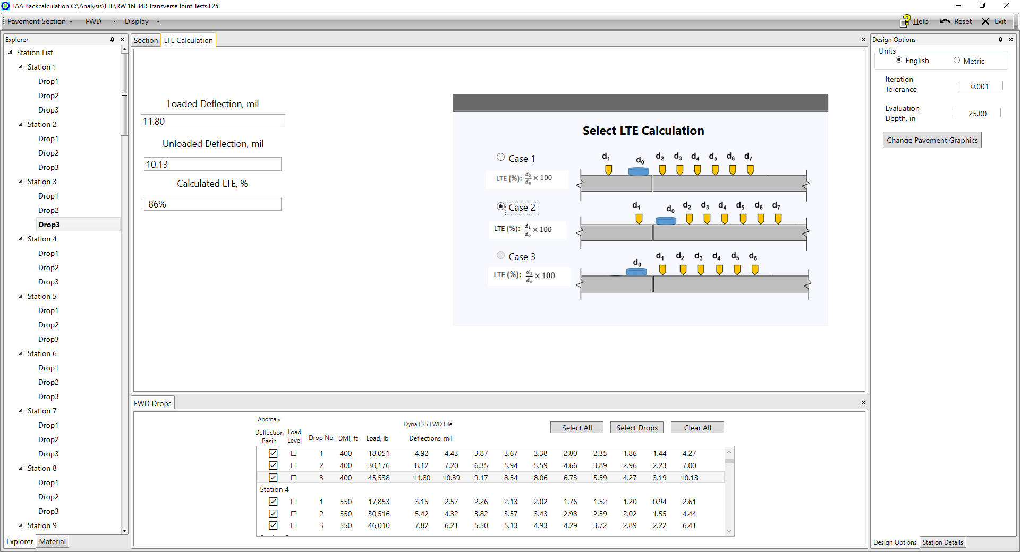
Figure 5-15. LTE calculation example

Error Messages
There are two types of error messages in BAKFAA: user input error (due to incorrect input by the user) and FWD file error (due to missing or misplaced data in FWD files).

User Input Errors
BAKFAA gives the following error messages related to input parameters:
- Seed Modulus: The input for seed modulus value should be larger than zero.
Error Message: Only values larger than 0 are allowed for Seed Modulus.
- Poisson’s Ratio: The input for Poisson’s Ratio should be between 0 and 0.5.
Error Message: Acceptable range for Poisson’s Ratio is 0-0.5.
- Interface Parameter: The input for Interface Parameter should be 0 or 1.
Error Message: Acceptable values for Interface Parameter are 0 or 1.
- Layer Thickness: the input for pavement layer thickness should be larger than zero, except for the last layer in the structure.
Error Message: Zero is not acceptable for layer’s thickness except for last layer (Subgrade)
Error Message: Negative values are not acceptable for layer thickness.
- Iteration Tolerance: the input for iteration tolerance should be between 0 and 1.
Error Message: Values less than or equal to 0 are not acceptable for iteration tolerance.
- Deflection in “View FWD File” sub-window: The input for measured deflection should be larger than zero.
Error Message: Only values larger than 0 are allowed for deflection.
- Load in “View FWD File” sub-window: The input for load should be larger than zero.
Error Message: Only values larger than 0 are allowed for load.
- Pavement structure: Layers cannot be added below the subgrade.
Error Message: <Material> layer cannot be presented below the Subgrade layer.
- Pavement structure: More than one subgrade layer cannot be added.
Error Message: Only one subgrade layer can be presented in the pavement structure.

FWD File Error
Depending on the type of corruption in the FWD file, an error message will pop up identifying the error type and the line in which the error occurred in the file.

Advice and Reminders
- The XML file generated by clicking “Pavement Section” then “Save Pavement Section” button can contain both pavement structure and FWD data or only pavement structure data, depending on the user selection.
- A subgrade layer has restrictions on where it can be placed in the structure, and only one subgrade layer can be present. If these restrictions are limiting user configuration, a “User Defined” layer with the same layer parameters does not have any restrictions and functions identically to the subgrade in BAKFAA.
- In a backcalculation analysis, there may exist many solutions (such as different combinations of layer modulus values) for a given pavement structure and measured FWD deflections. Backcalculation may be very sensitive to the input parameters such as seed modulus and iteration tolerance. Backcalculation often requires many iterations and use of engineering judgment to find the most reasonable results. Reasonable results are obtained when the backcalculated modulus values are both within an acceptable range and the RMSE is small (less than 5%).
- Backcalculation results are not always reliable for pavement systems with four layers or more. If possible, consider combining pavement layers with comparable modulus values and introduce them as one layer. In addition, backcalculation results for thin layers (less than 3 in. or 7.5 cm) may not be reliable. If possible, consider combining the thin layers with another layer.
- Adding a stiff layer (such as bedrock) as the last layer in the pavement system may improve the accuracy of the backcalculation analysis results. Where applicable, this should be based on construction records, geotechnical investigation, or knowledge of the site.
- Consider excluding sensors with negative offsets or sensors with errors from the backcalculation analysis.

References
American Association of State Highway and Transportation Officials. “Pavement Deflection Data Exchange: Technical Data Guide, Version 1.0”, 1998.
ASTM International. (2023), ASTM D5858-96(2020): Standard Guide for Calculating In Situ Equivalent Elastic Moduli of Pavement Materials Using Layered Elastic Theory.
ASTM International. (2023), ASTM D7228-06a(2020): Standard Test Method for Prediction of Asphalt-Bound Pavement Layer Temperatures.
Federal Aviation Administration Advisory Circular. (2011), Advisory Circular No. 150/5370-11B: Use of Nondestructive Testing in the Evaluation of Airport Pavements.
Federal Aviation Administration Advisory Circular. (2018), Advisory Circular No. 150/5370-10H: Standard Specifications for Construction of Airports.
Flannery, Brian P., Press, William H., Teukolsky, Saul A., Vetterling, William T. “Numerical Recipes in Fortran”. Cambridge University Press, 1992, Section 10.4.
Heukelom, W. and Klomp, A.J.G. (1962) Dynamic Testing as a Means of Controlling Pavement during and after Construction. Proceedings of the 1st International Conference on the Structural Design of Asphalt Pavement, Ann Arbor, Michigan, 20-24 August 1962, 667-685.
Rinde, J. A. "Poisson's ratio for rigid plastic foams." Journal of applied polymer science 14, no. 8 (1970): 1913-1926.
Samsonov, Gregory V. Handbook of the Physicochemical Properties of the Elements. Springer Science & Business Media, 2012.

